**Year 4 MSci Project**

**Research Journal**

**Anwesha Sahu**

Supervisor: Dr Ian Stevens

Project Partner: Christopher Lenthall

**Saturday, 24th September 2022**

First read

**Paper:** Aniyan et Thorat. **2017**

|  |  |  |  |  |
| --- | --- | --- | --- | --- |
| Radio galaxies (RG) | Fanaroff-Riley radio galaxies (FR) | FR I | Square Kilometer Array (SKA) | Graphic Processing Units |
| CNNs | Bent-tailed morphology (RG) | FR II | Shallow learning methods | Deep Neural Networks (DNNs) |
| Ancillary data | Morphology |  |  |  |

Introduction

* SKA advent results in high data volumes
* Science level data volume is formidable
* For instance, source density with SKA is 6.2 x 104 sources per square degree
* Typical process:
  + Use source finding software
  + Generate source and/or component catalogues
    - Difference between source and component?
  + Combine components into single source where needed
    - Especially important for extended sources
* **DL and CNNs to classify extended extragalactic radio sources: AGN-powered radio galaxies** 
  + Previous notes on AGNs (double-check pls)
    - Active galactic nuclei
    - Mass accreting into supermassive black holes in galactic cores
    - Immense temperatures, brightness
    - Also known as quasars
    - Brightest known objects in visible universe
* DNNs have been beating all other shallow learning algorithms by huge margins
* Features for classifying radio galaxies:
  + Morphology
  + Spectral Index
  + Host galaxy brightness
    - Optical
    - Infrared
  + Host galaxy spectra/type
* If restrict to morphology only, can find:
  + FR classification
  + Wide-angled tailed
  + Narrow-angled tailed radio galaxies
* This paper:
  + Study restricted to classifications on basis of radio morphology

*To be continued*

**Paper:** Vega-Ferrero et al., 2022

**Tuesday, 27th September**

See resolution

Read about Background AGNs

**Wednesday, 28th September**

* Making code to read fits file

**Friday, 30th September**

* [Cutout2D](https://docs.astropy.org/en/stable/api/astropy.nddata.Cutout2D.html) from astropy for cutting out specific bit of a matrix

Reading Notes: Radio Structures

<https://en.wikipedia.org/wiki/Radio_galaxy>

* Radio galaxy = galaxy with giant regions of radio emission
* Jansky = spectral flux units named after Karl Jansky
* 10 MHz – 100 GHz = radio waves
* Giant radio galaxies != ordinary radio galaxies
  + Can extend to larger scales i.e several megaparsecs across

Radio loud active galaxies = synchrotron emission

* Inferred from smooth broad-band nature
* Strongly polarised
* Particle accelerations occur

Radio Structures

* Radio-loud quasars
  + Wide range of structures in radio maps
  + **Lobes** – very common large scale structure
  + Plumes too

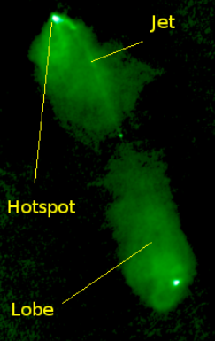 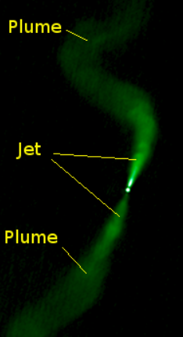

* Classical double = FR II with clear hotspots
* WAT = source intermediate btn standard FR I and FR II structure

Remember these setting for SAO9

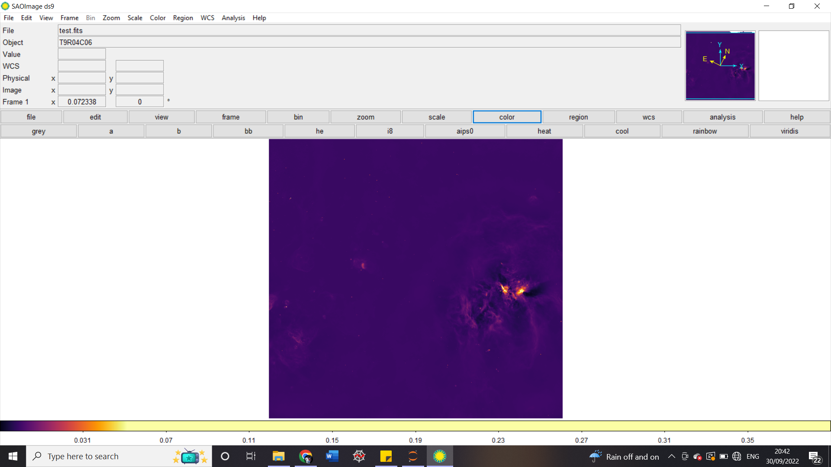

**3rd October 2022**

<https://ui.adsabs.harvard.edu/classic-form>

<https://ui.adsabs.harvard.edu/abs/2022arXiv220615131K/abstract>

Radio galaxy June 2022 paper

To do:

* ~~Set up computer~~
* Run Chris’s code
* ~~Run my own code~~
  + ~~Convert fits to image file~~

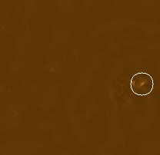

* + Save image file in hard drive
  + Do for 10 images (write function)
  + Make ML code
* Skim read June 2022 paper
* Read up on GANs

Next steps

* Segment each image into 4
* Get the brightest region in each segment
* Crop further and get a rectangular region around brightest region
* **Reading:** <https://machinelearningmastery.com/what-are-generative-adversarial-networks-gans/>
* **Tutorial GANs:** <https://realpython.com/generative-adversarial-networks/>
* **Reading (**Heartworm nebula**):** [**https://www.astro.princeton.edu/~gk/A403/polytrop.pdf**](https://www.astro.princeton.edu/~gk/A403/polytrop.pdf)
* **Reading:** <https://ui.adsabs.harvard.edu/abs/2022arXiv220615131K/abstract>

Radio galaxy June 2022 paper

* **Coordinate Systems:**
  + FK5 – Right ascension (0-24hrs) and declination (-90 to +90)
  + J2000
  + Galactic – SgA* is at longitude 0
    - Galactic centre is 360, 0



* + World Coordinate Frame
* Load VO Tables in Python
* Work out why coordinates are different, for brightest spot
* Get background help with Obs Lab (Aegean point source)

(MNRAS paper on details)

**4th October, 2022**

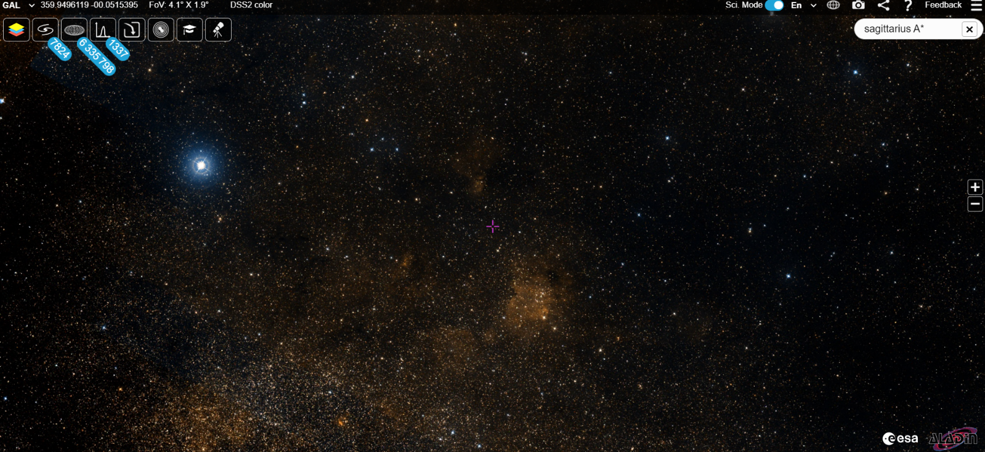

**Meeting notes**

* Source catalogue 🡪 not a very intelligent catalogue
  + Catalogue based on the data when opened in DS9
  + **Virtual Observatory Table (VO Table)** 
    - **comp.vot**
      * **Can plot map of coordinates of points, and then overlay on the image in DS9**
    - **Ian will upload the catalog (whole lot ~0.5 GB)**
    - **lon, lat error in lon, error in lat, int flux, a & b (2D Gaussian related error)**
    - **Islands are sources near each other** 
      * **If 2 🡪 could be 2 AGNs close to each other**
    - **Aegean tools (for background)**
    - [**https://github.com/PaulHancock/Aegean**](https://github.com/PaulHancock/Aegean)
* ESA Sky is useful tool to look at objects in different wavelengths
  + <https://sky.esa.int/>
* Make sure image and coordinate and location of object is recoverable
* Think that background may be dealing with Aegean method 🡪 paper in MNRAS ***Report***

**5th October 2022**

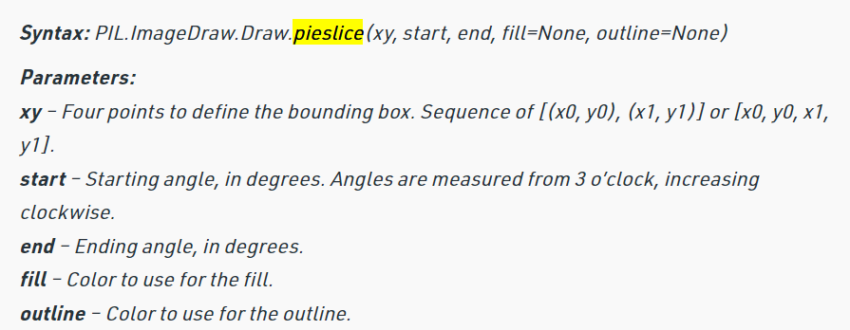

<https://www.geeksforgeeks.org/python-pil-imagedraw-draw-pieslice/>

* Note that changing colour scheme affects where the ROI is detected. BrBg is a good one to use
* Come back to coding later
* Do reading now
* **Reading:** <https://machinelearningmastery.com/what-are-generative-adversarial-networks-gans/>
* **Tutorial GANs:** <https://realpython.com/generative-adversarial-networks/>
* **Reading (**Heartworm nebula**):** [**https://www.astro.princeton.edu/~gk/A403/polytrop.pdf**](https://www.astro.princeton.edu/~gk/A403/polytrop.pdf)
* **Reading:** <https://ui.adsabs.harvard.edu/abs/2022arXiv220615131K/abstract>

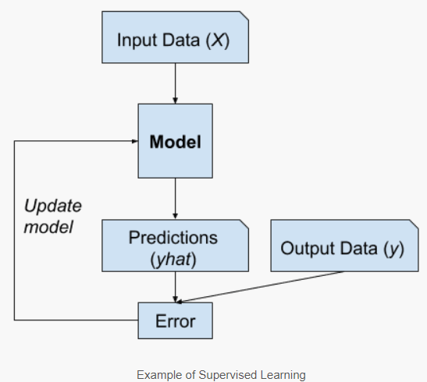 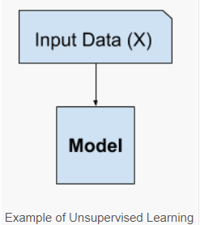

|  |
| --- |
| **Me and my GANs** |
| * Generative Adversarial Networks * Generative modelling with deep learning methods such as CNNs * Generative modelling = unsupervised ML * **Key = frame the problem as supervised problem with 2 sub-models**   + Generator model = generate new examples   + Discriminator model = classify example as either real or fake (generated)   + **Then** train both models together in zero-sum game, or *adversarial*     - Till the **discriminator** model is **fooled ~ half the time** * **Discriminative vs Generative modelling**      * **“***Approaches that explicitly or implicitly model the distribution of inputs as well as outputs are known as generative models, because by sampling from them it is possible to generate synthetic data points in the input space.***”** Page 43, [Pattern Recognition and Machine Learning](https://amzn.to/2K3EcE3), 2006. * Adversary = noun, one’s opponent in a contest, conflict, or dispute   **Generator Model**   * Fixed length random vector taken as input * Sample generated in the domain * Vector drawn from Gaussian distribution, randomly * Vector seeds the generative process * Post-training, points in this multi-dimensional vector space will correspond to points in the problem domain 🡪 compressed representation of data distribution   **GAN**    Related topics for further investigation:   * GANs and CNNs * Conditional GANs   MIT Arxiv tutorial: <https://arxiv.org/pdf/1701.00160.pdf> |
| **Tutorial Time for GANs** |
| <https://realpython.com/generative-adversarial-networks/>  **TensorFlow tutorial is better**  [**https://www.tensorflow.org/tutorials/generative/dcgan**](https://www.tensorflow.org/tutorials/generative/dcgan)  **Videos to watch**  [**https://www.youtube.com/watch?v=QcLlc9lj2hk&list=PLtBw6njQRU-rwp5__7C0oIVt26ZgjG9NI&index=4**](https://www.youtube.com/watch?v=QcLlc9lj2hk&list=PLtBw6njQRU-rwp5__7C0oIVt26ZgjG9NI&index=4)  [**https://www.youtube.com/watch?v=-WbN61qtTGQ&list=PLtBw6njQRU-rwp5__7C0oIVt26ZgjG9NI&index=5**](https://www.youtube.com/watch?v=-WbN61qtTGQ&list=PLtBw6njQRU-rwp5__7C0oIVt26ZgjG9NI&index=5)  [**https://www.youtube.com/watch?v=AALBGpLbj6Q&t=2231s**](https://www.youtube.com/watch?v=AALBGpLbj6Q&t=2231s) |

Main coding goal:

* Get images cropped and sorted and saved and stuff

**Thursday, 6th October 2022**

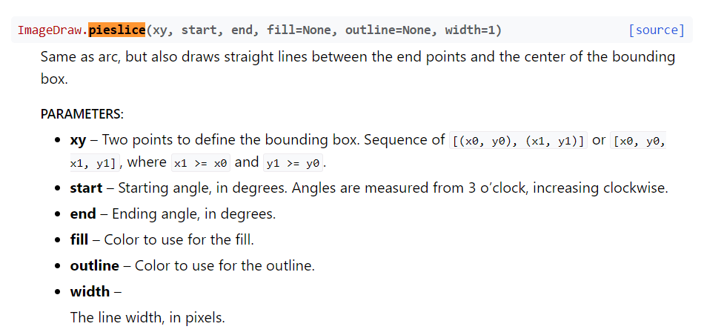

<https://pillow.readthedocs.io/en/stable/reference/ImageDraw.html>

Made flow chart for plan on what to do and when

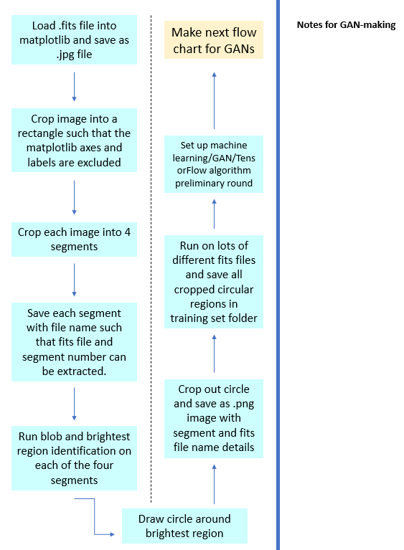

<Charts.pptx>

**Friday, 7th October 2022**

* Can save image as fits files
* But fits files need headers
  + This is where coordinates come in :/

Weekend to-do list:

* ~~Make circles and cropper tasks work~~
* ~~Save as jpg files~~
* Do for 10 images
* Continue watching GANs documentary
* Skim read June 2022 paper
* Read about how activation functions come into play
* Play around with DS9
* VOT Table read in Python?
* Apply logarithmic transformation to the image
* Go through segmentation and deblending code, Chris uploaded

**Saturday, 08 October 2022**

Making circle and cropper tasks work

Useful but not really <https://www.geeksforgeeks.org/python-pil-imagedraw-draw-pieslice/>

* Making a circle crop is proving too annoying, too much time
* Instead, use rectangular/square cropping

Current file: **OpeningFitaAsImage_v2.ipnyb**

Main ROI

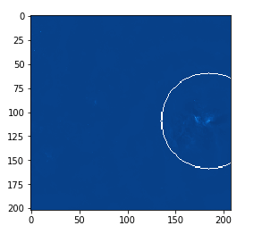

Cropped ROI

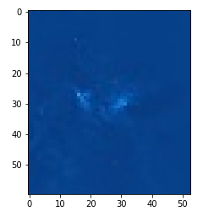

Attempted log scale for image above

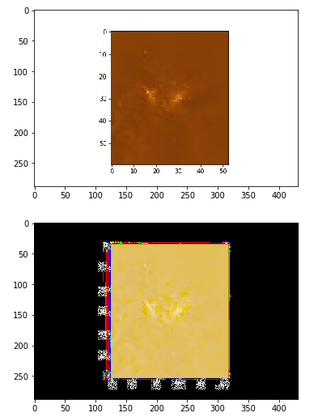 🡪 needs fixing

Attempted log scale again

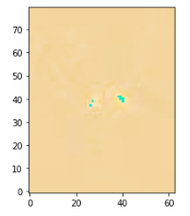

[..\ProjectCodingFiles\OpeningFitaAsImage_v2.ipynb](../ProjectCodingFiles/OpeningFitaAsImage_v2.ipynb)

* Next, turn into a function such that can do this for 10 images right away
* GET RID OF AXES AND LABELS! Want only image!!!!

**Monday, 10th October 2022**

* Note: got freshers flu over the weekend so did less work than anticipated

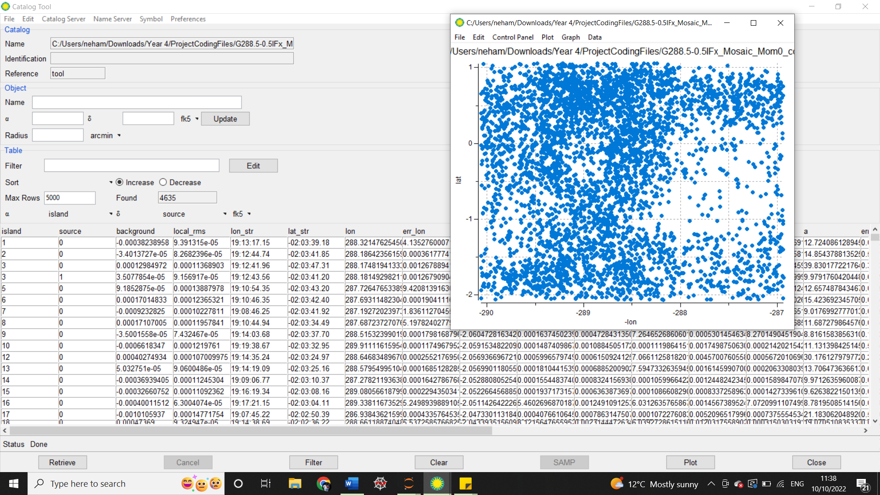

Able to save coordinates of points in scatter plot:

* Click save
* Then open in notepad++
* Means can load into python
* Overlay points with image, in python, to check number of sources

**Tuesday, 11th October 2022**

**Meeting Notes**

* Galactic coordinates are easier to work with for this survey
* FK 5 is also useful

Limitations with DS9:

* Artefacts radiating from bright regions
* Not finding all sources
* Falsely identifying some sources
* Simon Riggi software for picking out extended sources
  + <https://github.com/simoneriggi/caesar_base>
* Memorable and make a point – funny examples for presentations
* Get a functioning image recognition neural network by next week ~ish

Ideas for image processing:

* **Matplotlib 2D histogram**
* Fix cropping so axes are excluded
* Apply a Gaussian filter
* Look up other kinds of filters
* Get logarithmic image colour scale working
* Run blob detection algorithm and draw circles around ‘sources’
* Accept limitations
* Ignore the very large ones

**Thursday, 13th October 2022,**

To do:

* TensorFlow tutorial
* Make it work for giraffes and forks
* Read 2022 June paper
* Continue watching GANs video
* Explore matplotlib 2D histogram/cropping technique improve
* Find a way to get VOT loaded in Python directly if possible
  + <https://docs.astropy.org/en/stable/io/votable/index.html>
  + Astropy to the rescue

TensorFlow Tutorial

* Later

Blob detection

See [OpeningFitsAsImage_v3.2.ipnyb](../ProjectCodingFiles/FitsAsImageV3/OpeningFitsAsImage_v3.2.ipynb)

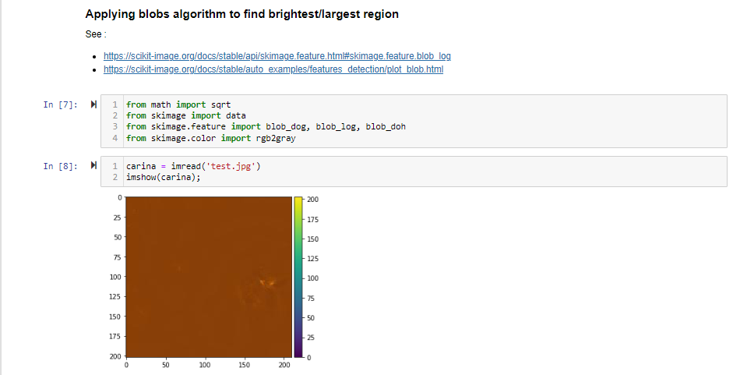

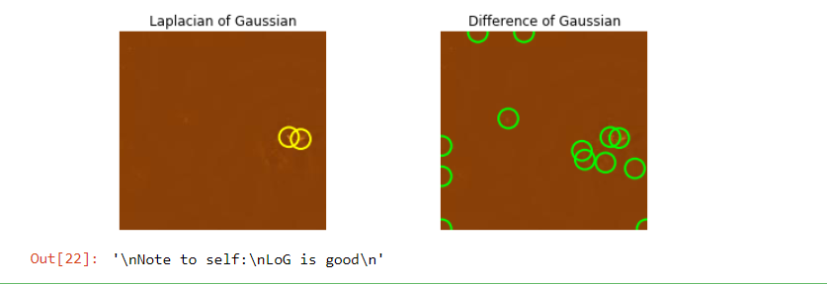

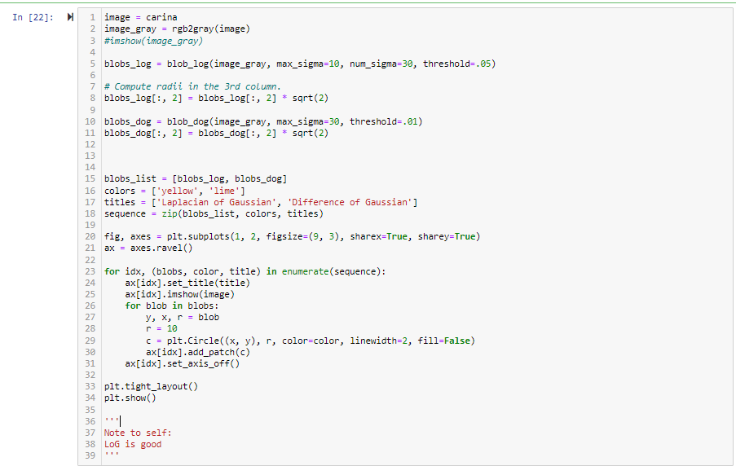

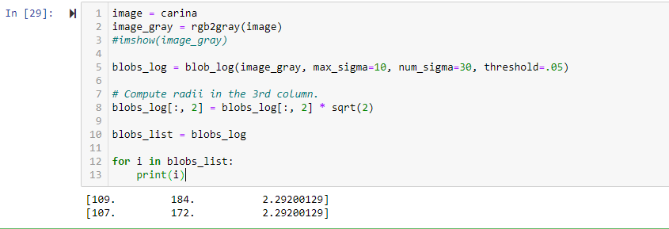

**Sunday, 16th October 2022**

Why using blobs log and not doh or dog:

* Laplacian of Gaussian = log
* Differential of Hessian = doh
* Differential of Gaussian = dog

<https://scikit-image.org/docs/stable/auto_examples/features_detection/plot_blob.html>

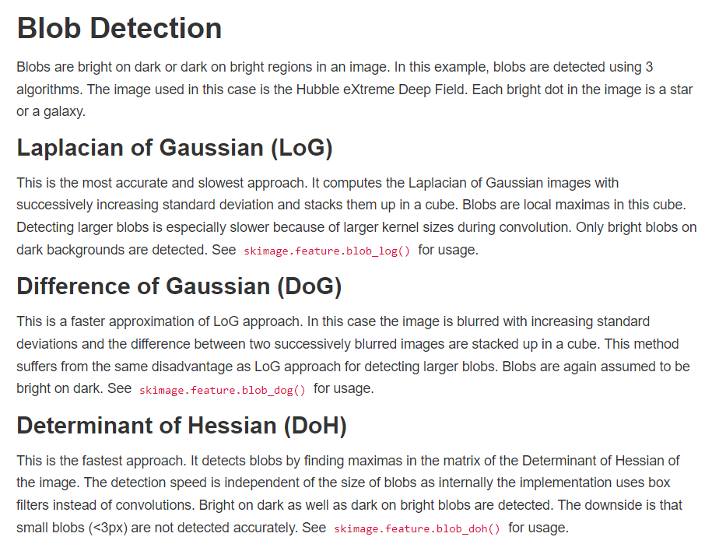

Blobs LoG works best as expected 🡪 is most accurate approach. Sticking to this

1. Plot image
2. Plot circle on it for largest blob
3. Crop out

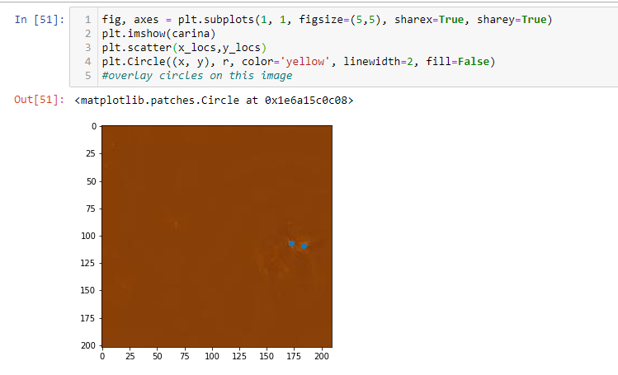

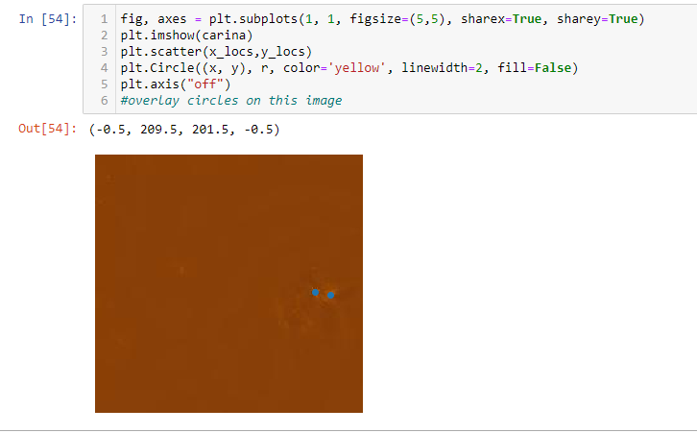

Finally got rid of axes

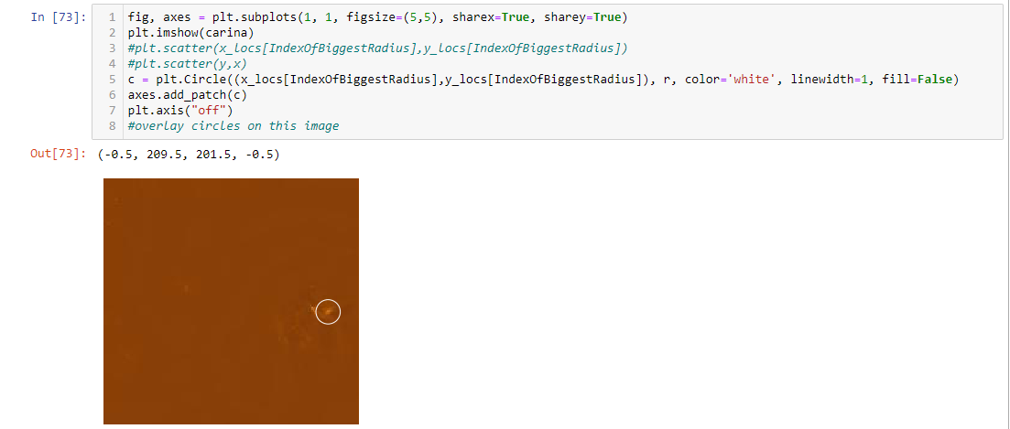

Well done 😊

**Key: need to add circle as a patch for it to be visible**

Make rectangle instead of circle

Refer to this tutorial then, and identify rectangle and crop out region: <https://splunktool.com/detect-rectangle-in-image-and-crop>

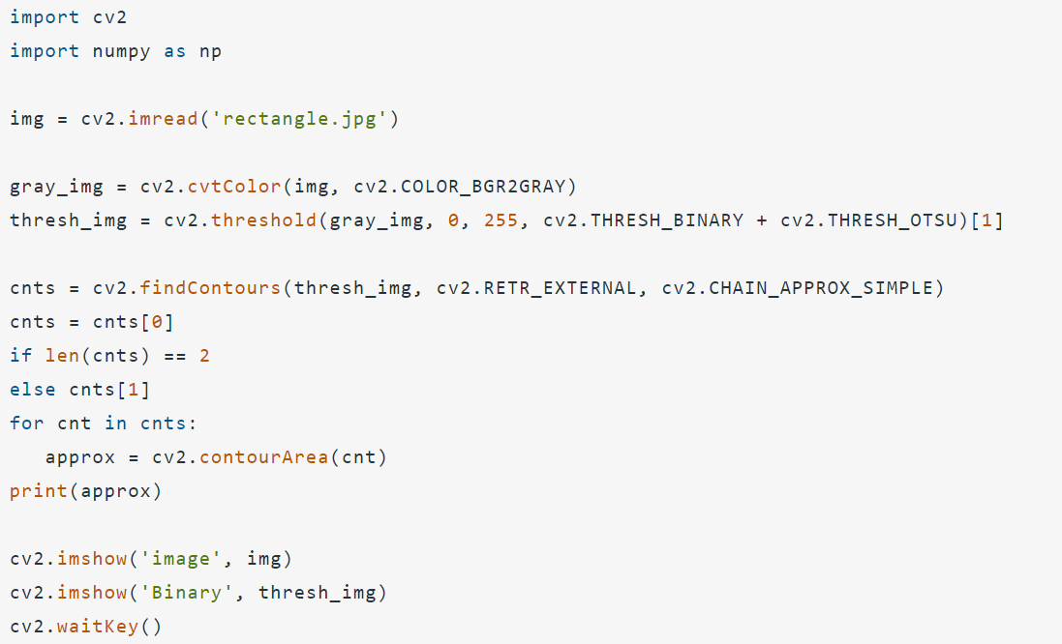

In progress:

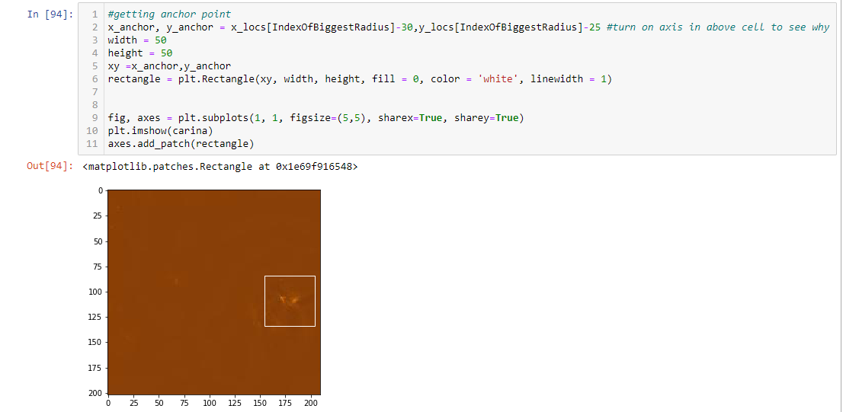

Annoyingly, image is saved like this:

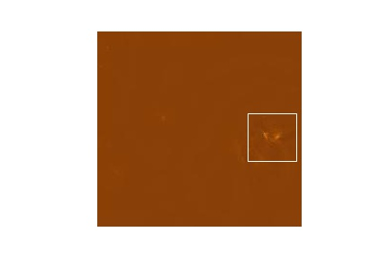

Hence using contours to identify rectangle

Method 1:

Not success because won’t crop

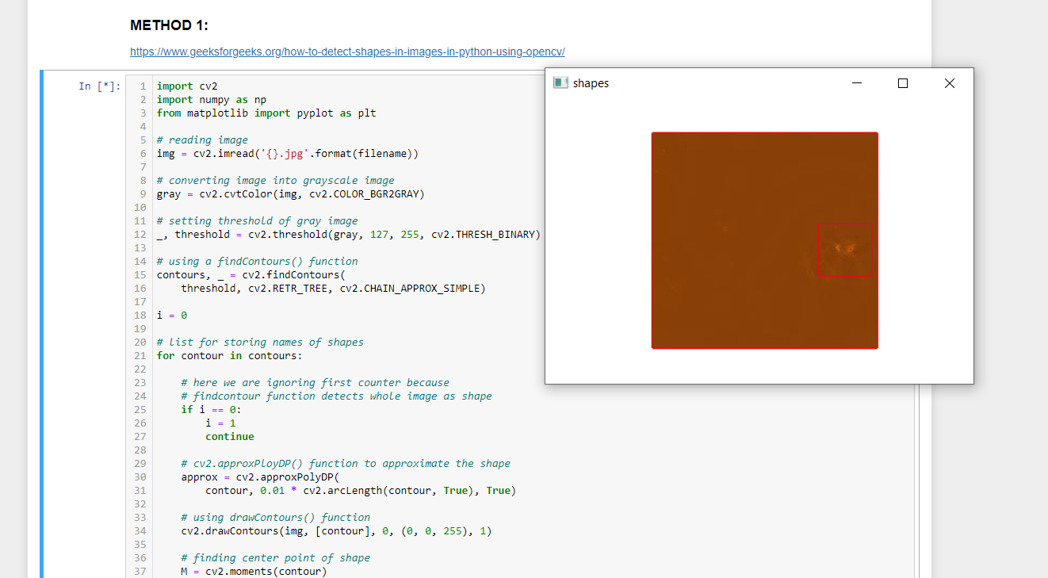

Nothing is working arghhhhh

Looked into three methods

NEW IDEA: just get the coordinates of the rectangles and then crop manually using OpenCV

<https://stackoverflow.com/questions/55840273/how-to-find-coordinates-of-the-rectangles-from-image-in-python-with-opencv>

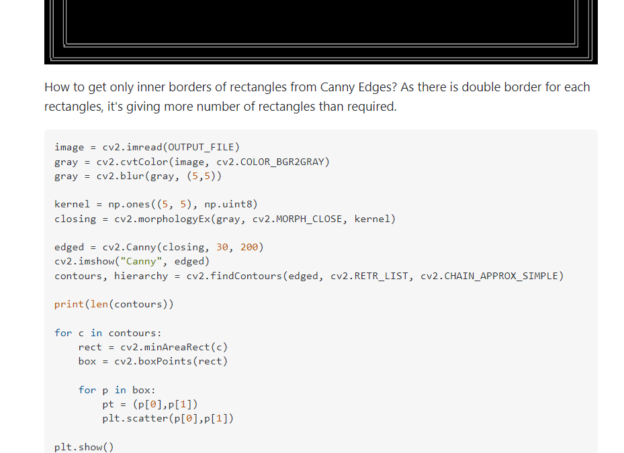

|  |
| --- |
| <https://www.tensorflow.org/lite/examples/object_detection/overview>  USE THIS WHEN DOING GANS AND DEEP LEARNING STUFF  **TensorFlow Object Detection** |

Working with Method 1 – I think I’m getting somewhere

Works!!!

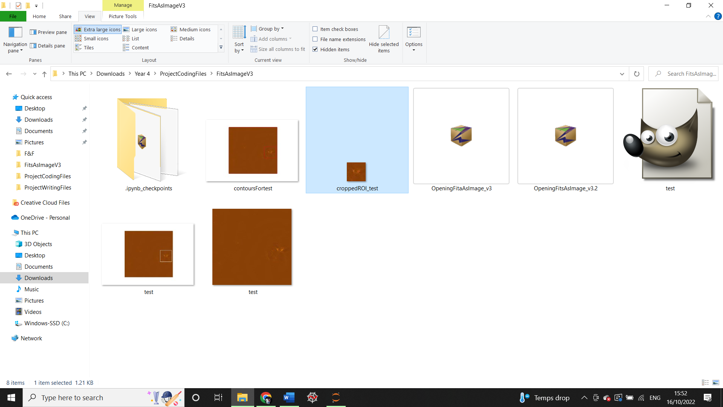

See section for Method 1

Moving on to [OpeningFitsAsImage_v3.3.ipnyb](../ProjectCodingFiles/FitsAsImageV3/OpeningFitsAsImage_v3.3.ipynb)

Next step:

1. ~~Make a function to do all of this automatically~~
2. ~~Download 5 other fits files~~
   * ~~Doing now~~
3. ~~Edit function code to change file paths for the fits files newly downloaded~~

Moved on to OpeningFitsAsImage_v3.3.2.ipnyb

1. Run on all 5 fits files

**Issue:**

* Nothing works
* Does not detect blobs in other images successfully
* Applied log scale to make it work but still not good enough
* Sad

Ideas:

**Colormap normalisations**

<https://matplotlib.org/stable/gallery/images_contours_and_fields/colormap_normalizations.html#sphx-glr-gallery-images-contours-and-fields-colormap-normalizations-py>

**Read VOT Tables, get locations of islands, extract/crop regions around them**

VOT Tables with astropy: <https://docs.astropy.org/en/stable/io/fits/index.html>

Handling .fits files: <https://docs.astropy.org/en/stable/io/fits/index.html>

**Play around with getting the correct logarithmic settings, then apply blob detection directly and get coordinates of centre of blob. Turn the region around each blob into a separate cropped image.**

* Need to feel like I’ve achieved something successfully haha
* Doing GANs tutorial now
* Reviewed image classification tutorial successfully

See tutorial.ipnyb [here](../ProjectCodingFiles/GANsTutorialTensorFlow/tutorial.ipynb)

**Tuesday, 18th October 2022**

* Continuing GANs tutorial
* Exploring ideas for finding correct logarithmic scales

Currently working on making GAN word for animal prediction

* Find a way to load images from laptop instead of MNIST or online dataset
* See this: <https://www.analyticsvidhya.com/blog/2021/04/generate-your-own-dataset-using-gan/>

Completed GANs tutorial for 5 epochs – time and computer constraints

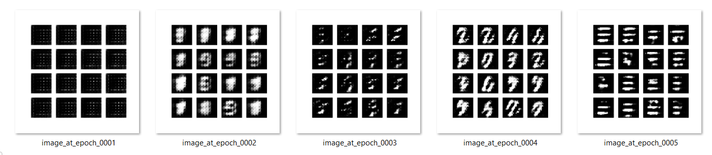

Ask Ian:

* How to load dataset into GAN without having to download from online dataset
  + <https://mlnotebook.github.io/post/GAN3/>
* Update on Python image processing

**Meeting notes**

Scale parameters in DS 9

Idea:

1. Apply log scale
2. Account for NANs
   * Mosaiced circles with overlaps
3. Apply masks with upper and lower limits – see Daniel’s contribution for code from cloud detector
4. Save images, see what happens
5. Blobs should not be bigger than 128 x 128

*Be careful with negative values with images 🡪 set all negatives to 0.000001 pixel brightness value*

Potential issues:

* Could find way too many blobs

In DS9:

Open scale parameters in linear scale setting

0, 0.001

Sets pixels greater than the upper limit to the upper limit

**Sunday 23rd October 2022**

To-dos:

* Logarithmic fits files images
* Save as images
* Improve blob detection
* Apply Gaussian filtering, see what happens
* See Jacob’s method for loading logarithmic images

Action plan:

1. Load fits file
2. Apply logarithmic scale
   1. Customise it

Blob detection straight away

* 1. Compare with SAO 9
  2. See SAO 9 parameters, etc

1. See what happens

Gaussian Filtering then blob detection

**Code file: OpeningFitsAsImage_v4.1.ipnyb** [here](../ProjectCodingFiles/FitsAsImageV3/Untitled.ipynb)

This is what SAO 9 sees

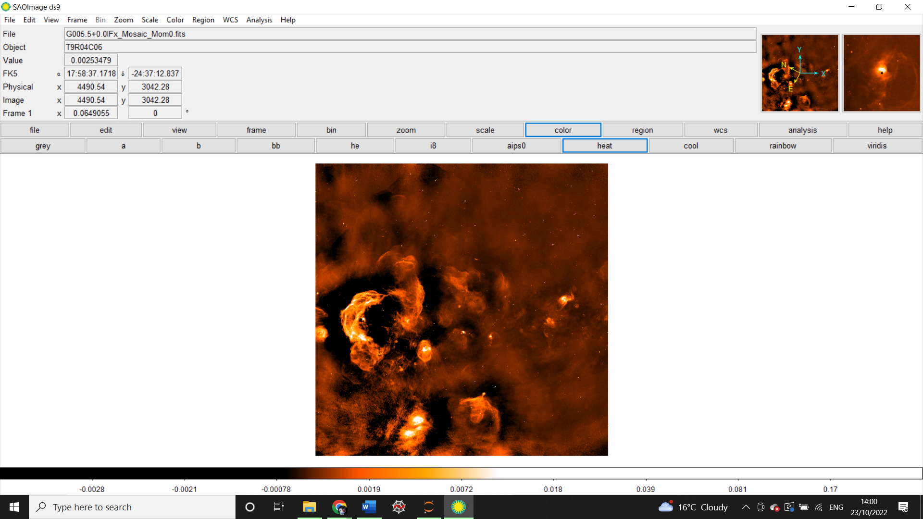

Will aim to get an image sort of like this at least, but in python

Opening in Python without any other processing, same file looks like this:

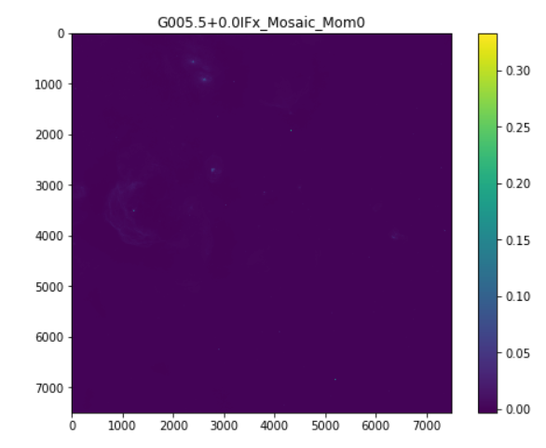

Applied log scale and threshold filter

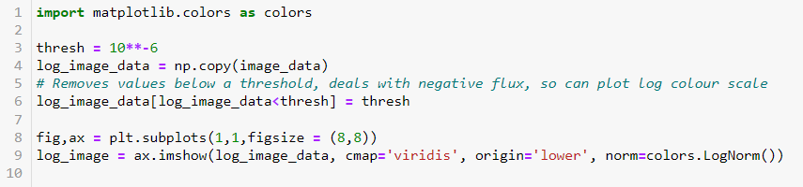

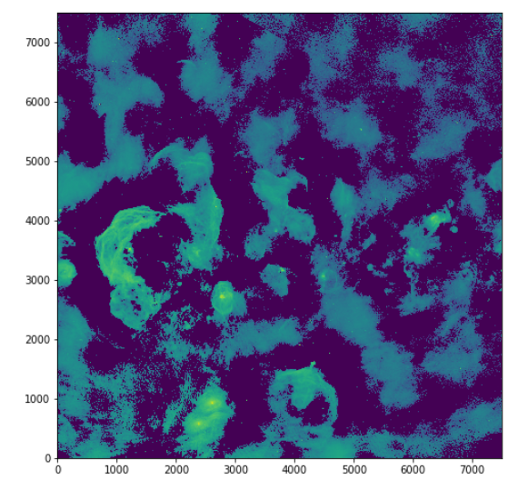

|  |  |
| --- | --- |
| **Thresh** | **Image** |
| 10^-6 |  |
| 10^-5 |  |
| 10^-4 |  |
| 10^-3 |  |
| 10^-3.5 |  |
| 10^-3.8 |  |
| **Notes**   * 10^-4 seems like a good one * 10^-3.8 seems better * Will go ahead with blob detection on both 10^-3.8 and 10^-4 | |

Able to successfully save the image

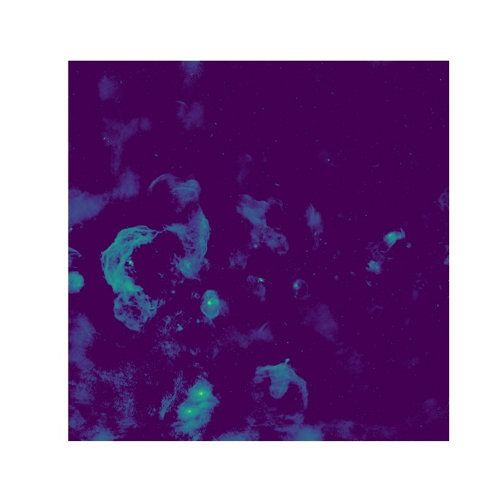

Now will apply blob detection algorithm

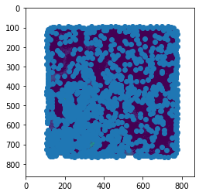

Too many blobs

|  |  |  |  |  |
| --- | --- | --- | --- | --- |
| **Min sigma** | **Max sigma** | **Num sigma** | **Threshold** | **Image** |
| 2 | 30 | 30 | 0.5 | 0 blobs |
|  |  |  | 0.5 | 12 blobs detected |
|  |  |  |  |  |
| 0 | 40 | 20 | 0.5 | 0 blobs |
| 0 | 40 | 80 | 0.5 | 1122 blobs detected |
| 10 | 40 | 80 | None | Over 97% CPU memory being used |
| 10 | 40 | 60 | None | Too much memory used |
| 10 | 40 | 20 | None | Too much memory |
| 10 | 20 | 20 | None | Too much memory |
| None | 10 | 20 | None | Eh |
| 1 | 40 | 80 | 0.05 | 1184 blobs detected |
| 1 | 30 | 50 | 0.05 | 1237 blobs |
| 1 | 10 | 10 | 0.05 | 1256 blobs |
| 1 | 10 | 10 | 1 | 0 blobs |
| 1 | 10 | 10 | 0.5 | 0 blobs |
| 1 | 30 | 10 | 0.5 | 0 blobs |
| 10 | 50 | 60 | 0.5 |  |

Tried another method which I found on stack exchange

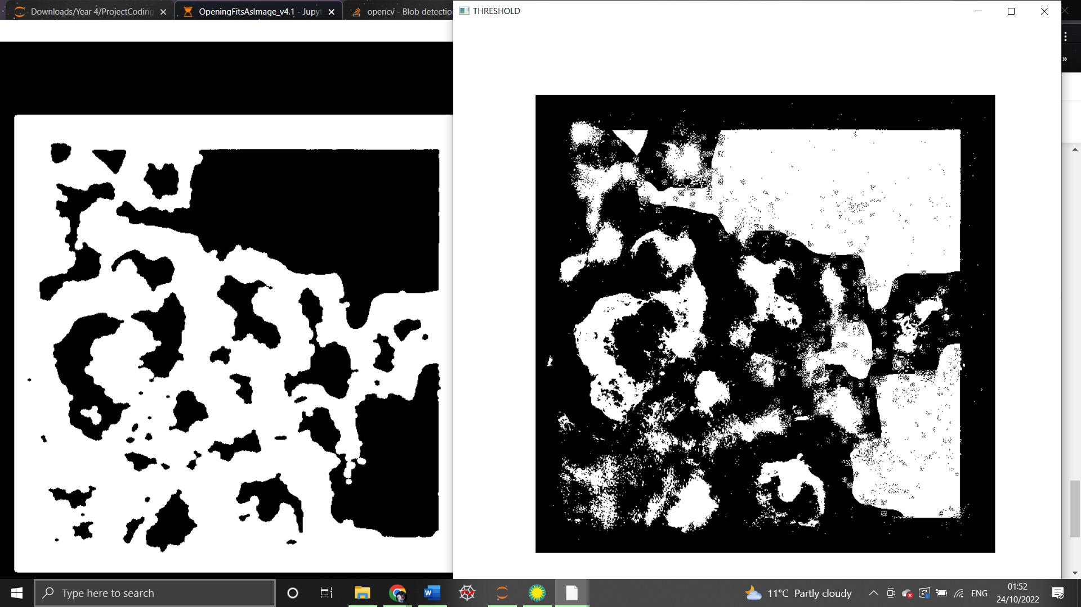

* Needs improvement 🡪 play around with it please
* <https://stackoverflow.com/questions/61432335/blob-detection-in-python>

**Monday, 24th October 2022**

To-do:

Understand how contours work in python and OpenCV

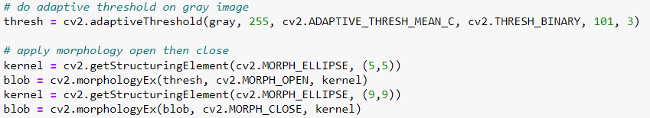

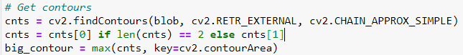

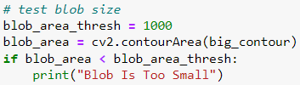



Documentation:

<https://docs.opencv.org/4.x/d7/d4d/tutorial_py_thresholding.html>

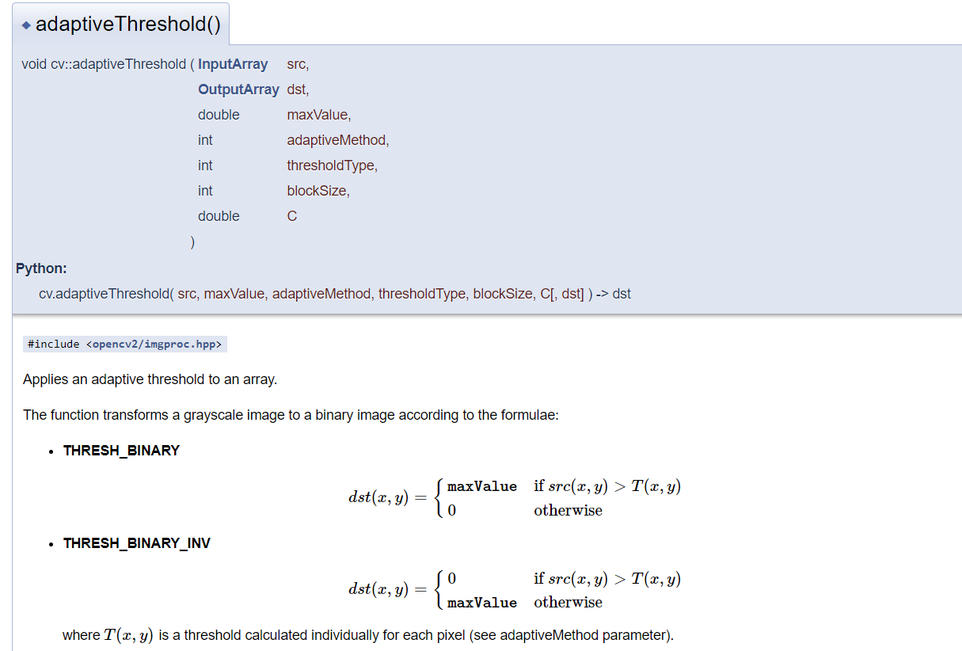

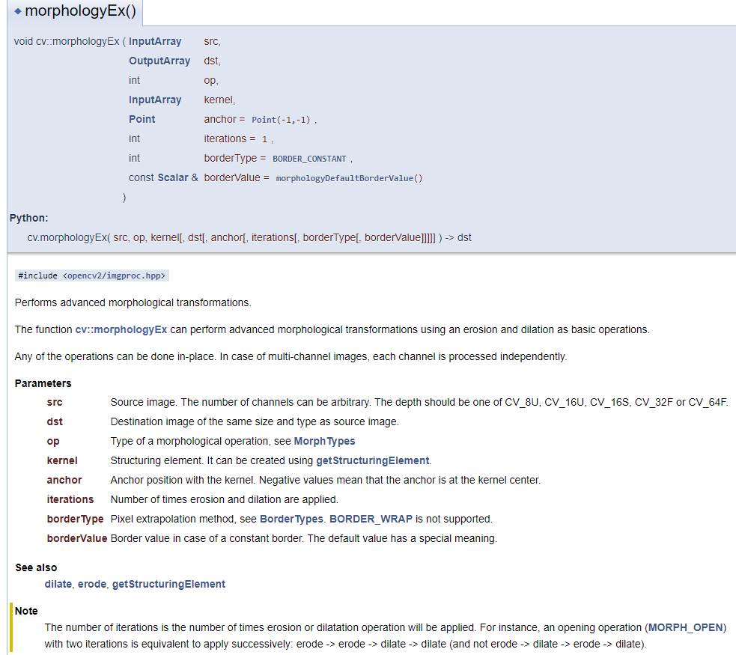

Cv2.MORPH.ELLIPSE / OPEN

<https://pyimagesearch.com/2021/04/28/opencv-morphological-operations/>

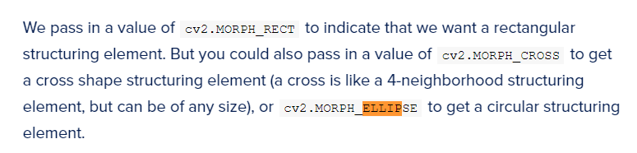

**Tuesday, 25th October**

* Find a happy medium for the red diamonds blob detection
* Continue exploring other blob method 🡪 new one
* Majority of radio galaxies are HII regions and are smaller



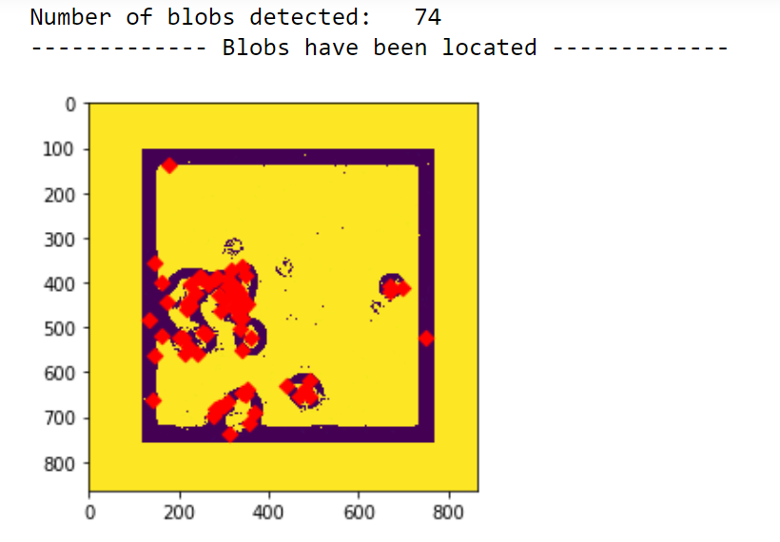

74 blobs detected - better than table previously recorded

**Saturday, 29th October 2022**

To-do:

* Use Google collab for something
* Play around with diamond blobs
  + – collab refuses to work
  + Looking for solutions
  + Meeting Owen on Wednesday, look at Jake’s messages

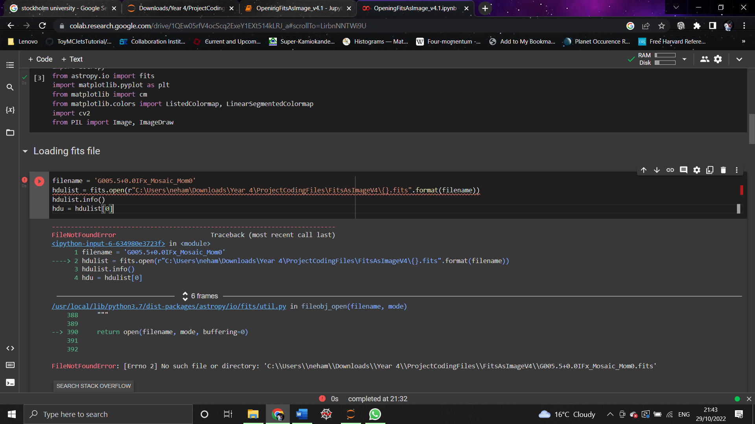

Colab, bruv, file exists, directory too bro

**Tuesday, 1st November 2022**

Running GAN for animals – cow

To load, attempt this [combo of cloud detector and GANs tensorflow tutorial]:

1. 
2. 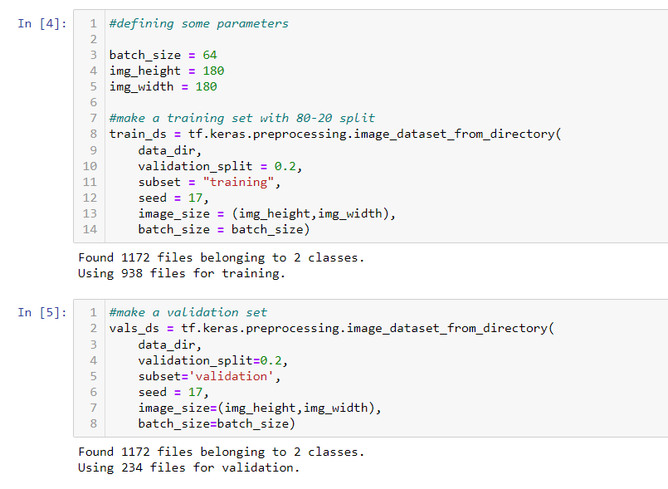
3. 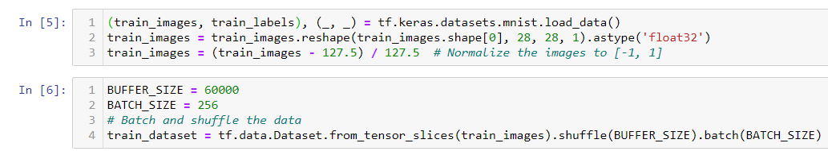

Continuing diamond blobs

Figure out how to use virtual GPU to save computational power

Colab v/s Kaggle <https://www.kaggle.com/product-feedback/147587>

* Registered on Kaggle with google account
* Kaggle GPU use: <https://www.kaggle.com/code/dansbecker/running-kaggle-kernels-with-a-gpu/notebook>

 Click +Create

Running diamond blob detection on Kaggle 🡪 same issue as before, file not found on Kaggle kernel but found when doing on Jupyter.

* Found potential solution: <https://www.kaggle.com/code/dansbecker/finding-your-files-in-kaggle-kernels/notebook>

Worked:

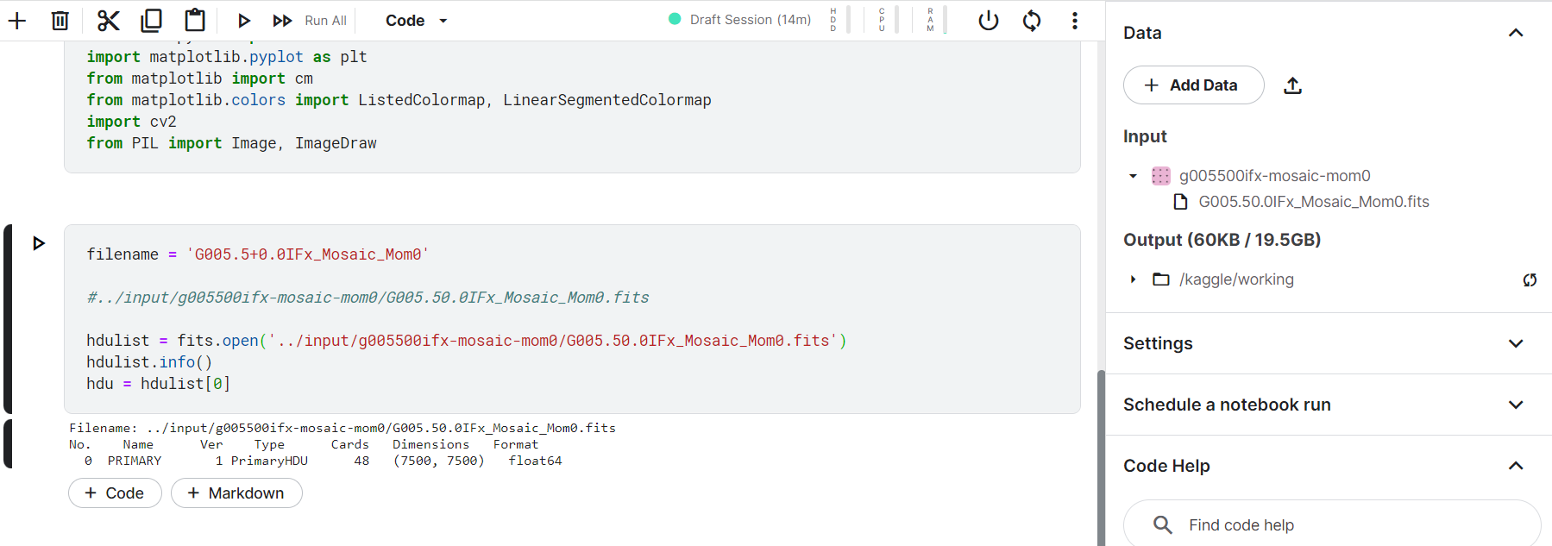

Need to upload to my Kaggle data, then get file path



Kaggle file name

**Thursday, 3rd November 2022**

Updates:

* Kaggle works but still debugging
* Want results so going back to Jupyter for now
* Will look at why Kaggle is mad later
* Meeting Owen later – ask about loading stuff for animals cow GAN tutorial
* Reading in afternoon/start work on report for IMPRS

|  |  |  |  |  |
| --- | --- | --- | --- | --- |
| **Min sigma** | **Max sigma** | **Num sigma** | **Threshold** | **Method** |
| 1 | 50 | 60 | 0.5 |  |
|  |  |  |  |  |
|  |  |  |  |  |
|  |  |  |  |  |

GANs continued

<https://pytorch.org/tutorials/beginner/dcgan_faces_tutorial.html>

Moving on to animalsGAN_v3.2 🡪 attempts method in Tuesday’s entry

* Didn’t work because format inconsistent

**Monday, 7th November 2022**

To-do:

* Reading
* GANs work
* Table above more results get

**Python file: OpeningFitsAsImage_v4.2**

|  |  |  |  |  |
| --- | --- | --- | --- | --- |
| **Min sigma** | **Max sigma** | **Num sigma** | **thresh** | **Image & number of blobs** |
| 1 | 50 | 60 | 0.5 | 74 |
|  |  |  |  |  |
|  |  |  |  |  |
|  |  |  |  |  |

MY BRAIN ISN’T WORKING. First step: Fix the border thingy, make this go away:

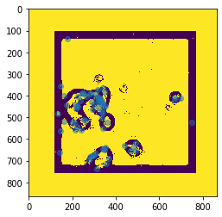



Original fits file for this: G005.5+0.0IFx_Mosaic_Mom0.fits

|  |
| --- |
| **Notes** |
| * When python opens fits files, it opens them as ndarrays * GANs accept ndarrays * ndarrays can be opened as images * do blob detection directly on the fits file opened image * make sure that the border thing or the white chunk doesn’t show up * get the coordinates of each of these blobs in terms of the coordinates of the fits file * save each blob as an image of its own * name each saved blob image as *fitsfilename_blob[blobnumber].jpg* |

**Python file: animalsGANs_V4.ipnyb**

Working with Carina nebula fits file

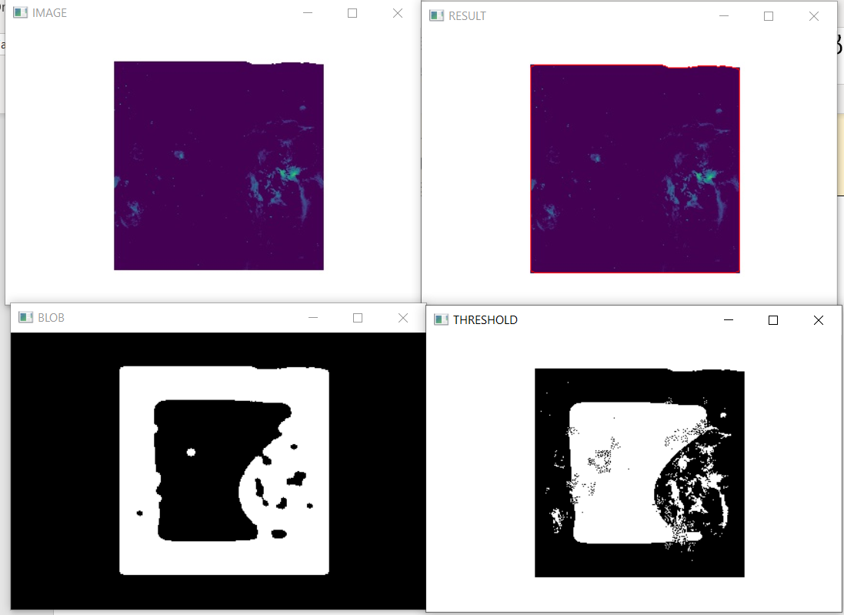

Now running blob detection on threshold image

Threshold image:

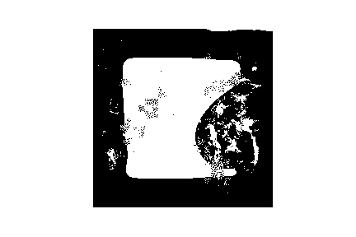

Blobs:

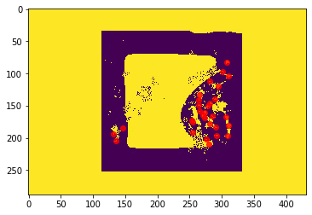

30 blobs found

|  |
| --- |
| **Matters of Concern** |
| * Where does the weird square thing come from * Perhaps changing the threshold from adaptive to a simpler one may find curiouser objects |

|  |
| --- |
| **Different kinds of thresholding** |
| **Otsu Binarisation**  <https://docs.opencv.org/4.x/d7/d4d/tutorial_py_thresholding.html>    Gives pretty neat results when compared to general thresholding methods    **KEY:** apply Gaussian filter first, then apply Otsu’s thresholding  Easy way to do this: |

Applying the above

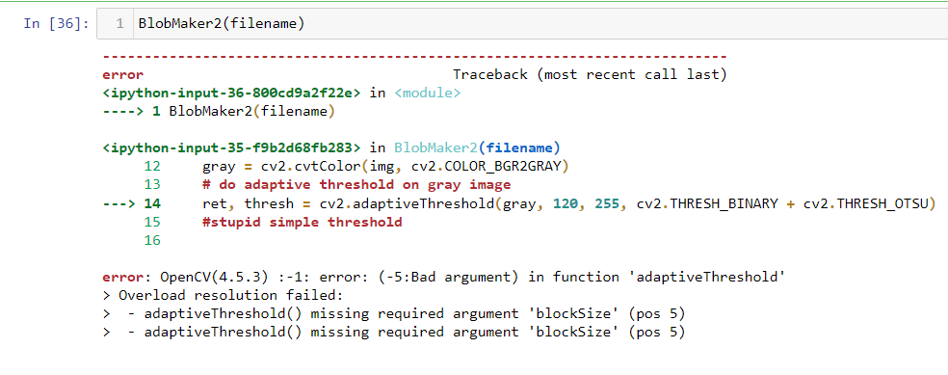

Debug this

See this for guidance <https://docs.opencv.org/4.x/d7/d4d/tutorial_py_thresholding.html>

**Tuesday, 8th November 2022**

**GANs plan:**

1. Sort out image processing first
2. Then save images (cropped ROIs) as .npy files
3. Upload these onto the cloud directory
4. Use these in the GAN – Jake’s repository uses colab and .npy datasets and this definitely works
   1. Key considerations:
      1. D and G should have about equal accuracies for GAN to produce useful results

**Abandon cv2 blobs approach**

|  |
| --- |
| **FIRST data** |
| <https://third.ucllnl.org/cgi-bin/firstcutout>  Readymade dataset:  <https://inspirehep.net/files/18d807615ef525a7a608e3cfd8939580>  **Step 1:**  [**https://cdsarc.cds.unistra.fr/viz-bin/cat/J/ApJS/259/31#/browse**](https://cdsarc.cds.unistra.fr/viz-bin/cat/J/ApJS/259/31#/browse)  Open source table in FTP  **Step 2:**  Get RA and Dec and plug into FIRST cutout website  <https://third.ucllnl.org/cgi-bin/firstcutout>  **Step 3:**  Download the image  ***See Jake’s automated program for downloading these files:*** [***https://github.com/jacobmorrisn/Y4-Project/blob/master/download_image_cutouts.ipynb***](https://github.com/jacobmorrisn/Y4-Project/blob/master/download_image_cutouts.ipynb) |

Make the shift to using Kaggle permanently

Make GAN for FIRST sources, apply to MeerKAT

Manipulate VOT tables

**FIRST Sources Downloading**

**Python file: Kaggle DownloadingFIRSTData**

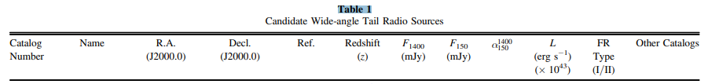

* Table 1 = WATs

Sources:

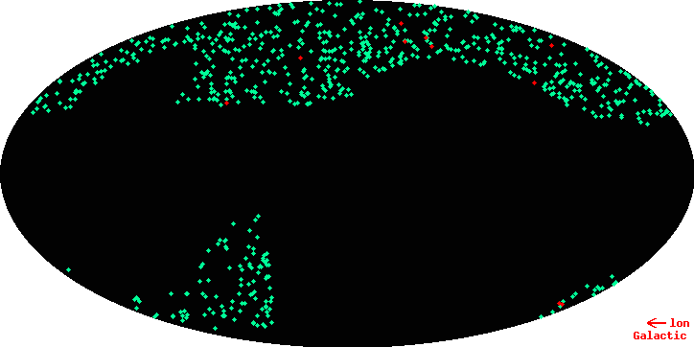

Got issues with Kaggle, then tried with Colab

Issues because:

* Selenium has been updated and something is not compatible with it

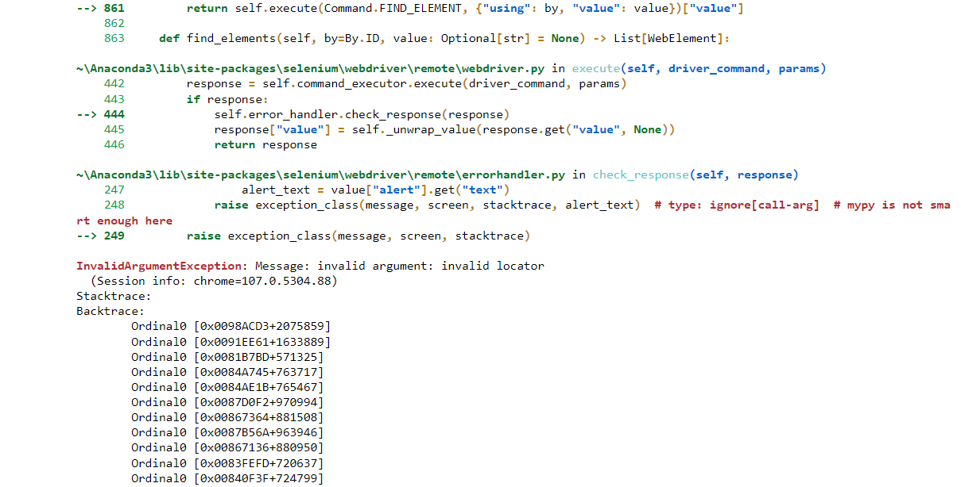

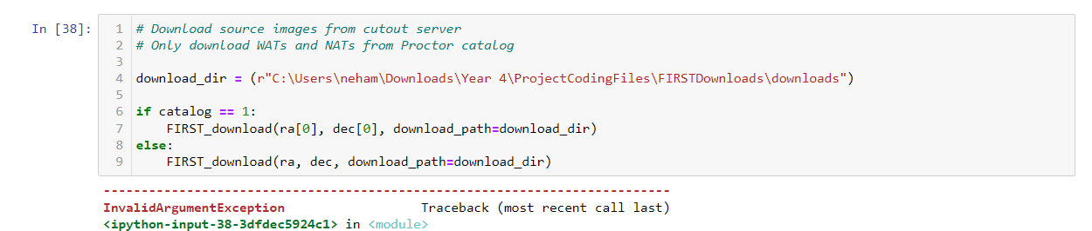

Will download everything manually

Manual download not working

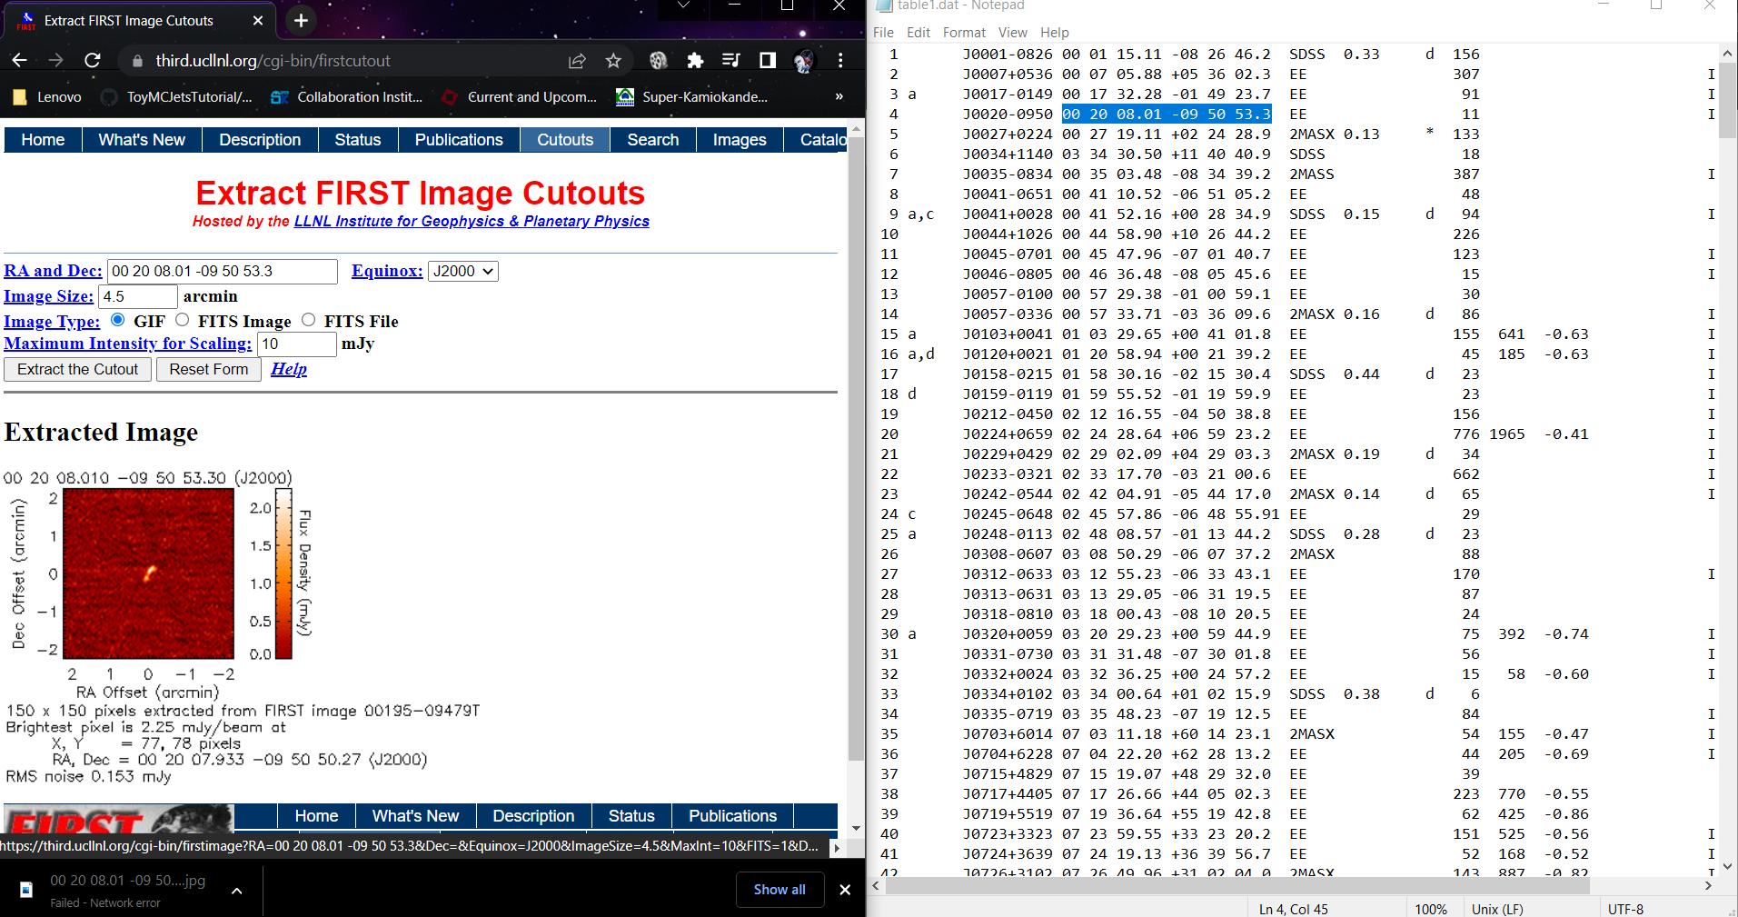

**Wednesday, 9th November 2022**

Idea: Apply Gaussian mask, simple Gaussian mask, then star finder algorithm used in AllSky cloud detector

**Friday, 11 November 2022**

To-do:

* Download 30 images from FIRST catalogue table 1 ✓
* Construct GAN

**Note:** Table 1 is WATs

**Sunday, 13th November 2022**

Style GAN 1: <https://evigio.com/post/how-to-use-custom-datasets-with-stylegan-tensorFlow-implementation>

Style GAN 2: <https://towardsdatascience.com/how-to-train-stylegan2-ada-with-custom-dataset-dc268ff70544>

More detailed StyleGAN 2 model: <https://towardsdatascience.com/generating-anime-characters-with-stylegan2-6f8ae59e237bv>

Currently attempting StyleGAN 1

* Made virtual environment
* Installed TensorFlow 1.15.0
* Installed cudnn

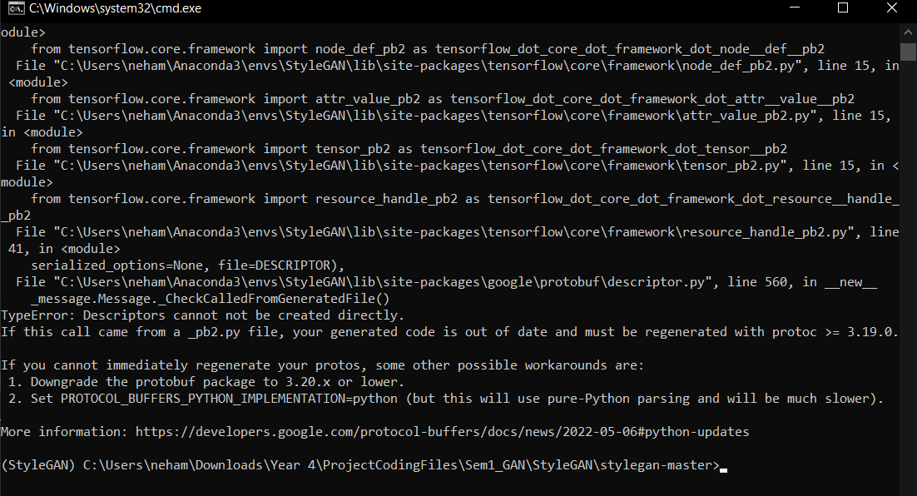

StyleGAN seems to have incompatibility issues with older version, attempting to use StyleGAN 2

StyleGAN3 <https://github.com/NVlabs/stylegan3>

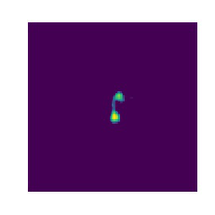

Do this tutorial:

[**https://machinelearningmastery.com/how-to-develop-a-generative-adversarial-network-for-a-cifar-10-small-object-photographs-from-scratch/**](https://machinelearningmastery.com/how-to-develop-a-generative-adversarial-network-for-a-cifar-10-small-object-photographs-from-scratch/)

Pre-requisites:

* Images need to be a specific format of np.ndarrays
* Use the above model!

**Tuesday 15th November 2022**

To-do:

1. Pre-process images:
   1. Get rid of nan values and crop images
   2. Normalise so all images are same size
   3. Save as .npy then make one big .npy file
   4. Make the GAN

* Able to crop images
* Able to save image as npy file
* Able to compile into ndarrays

[**https://keras.io/examples/generative/dcgan_overriding_train_step/**](https://keras.io/examples/generative/dcgan_overriding_train_step/)

**IT WORKS!**

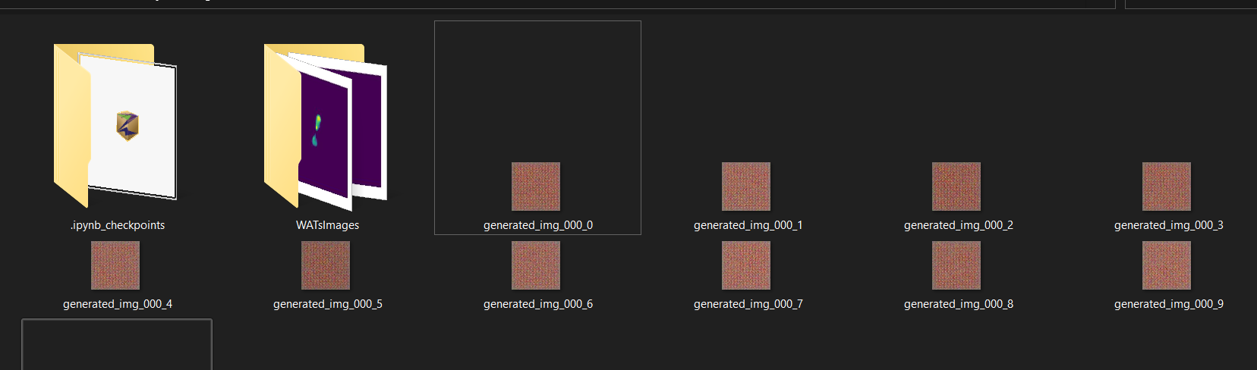

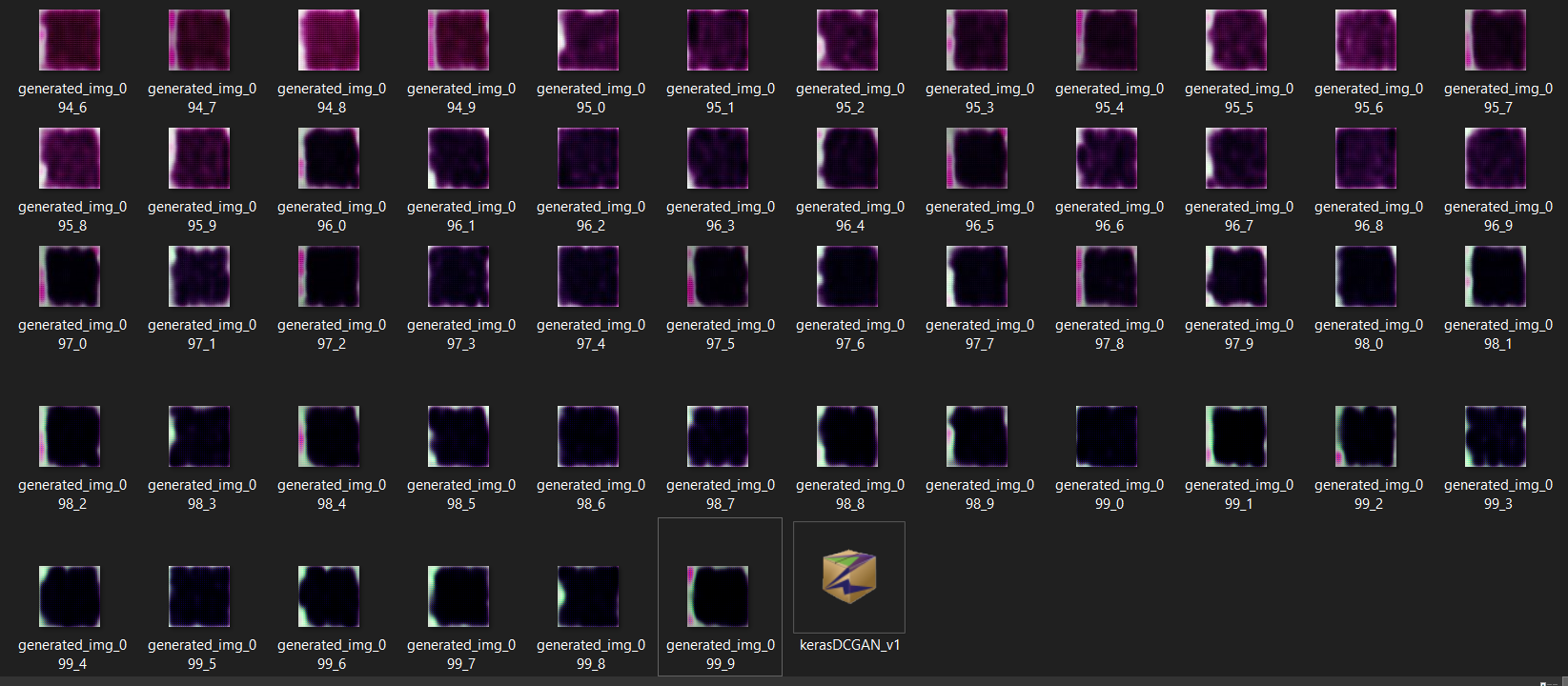

**Python file: kerasDCGAN_v1.ipnyb**

**Next steps:**

* Download all images of WATs
* Remove all the edges:
  + Write a fake program to create a simple model image set and then verify that we can control the GAN
    - Generate 1000+ images of blobs which are Gaussian spread/easy to understand
* Apply data augmentation and save the images
* Understand what each cell does and add comments/make a documentation
* Aim to get ~600 images in the training set
* Run GAN with 100 epochs

Fake image generator

**Option 1**

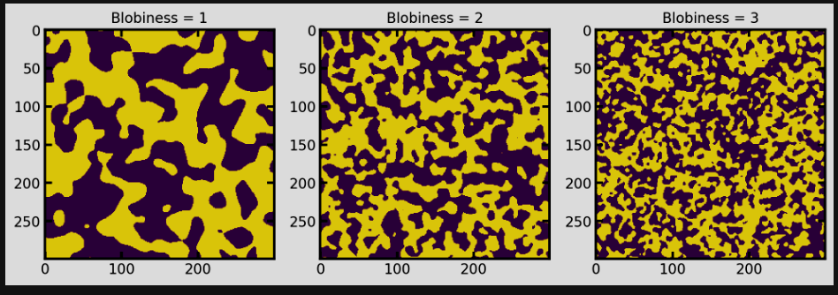

<https://porespy.org/examples/generators/tutorials/making_blobs.html>

**Option 2**

* This looks bit better

<https://www.geeksforgeeks.org/plot-2-d-histogram-in-python-using-matplotlib/>

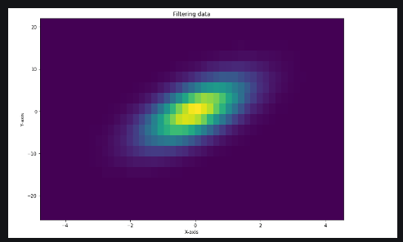

But instead of one blob, make two blobs

**Idea for project path:**

|  |
| --- |
| Using MeerKAT images, crop each image into 9 segments. Determine which category each of the segment falls into, manually. Use this to classify. Then train the GAN with this. |

**Wednesday, 16th November 2022**

Success:

* Removed big white border around image

As in,

This:



Became this:

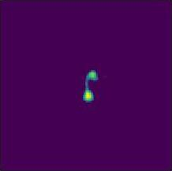

Now have this:

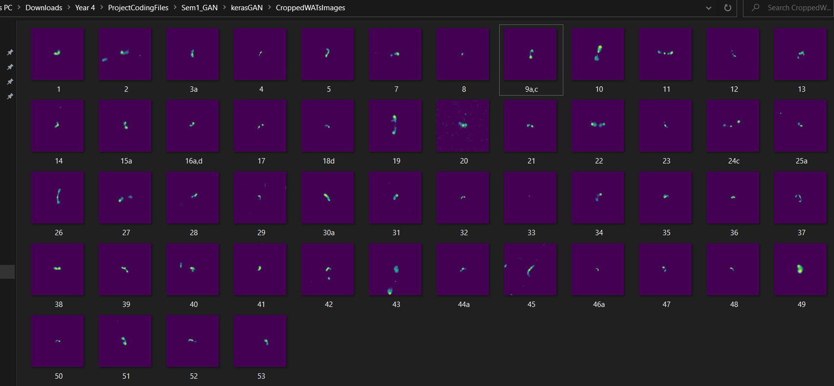

**Python file**: ImagePreProcessing.ipnyb

Next step:

* Making a fake image generator
* Using option 2 from Tuesday’s entry
* <https://www.geeksforgeeks.org/plot-2-d-histogram-in-python-using-matplotlib/>

**Thursday, 17th November 2022**

* Applied data augmentation by rotating each image by 90, 180 and 270 degrees

Results:

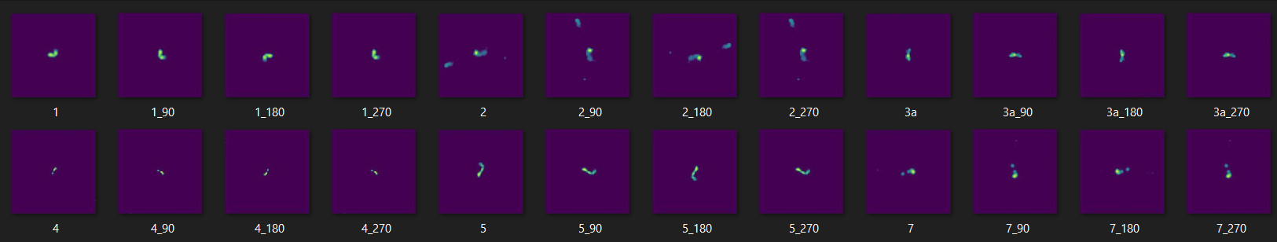

* Currently activation function is sigmoid
* See results
* Make activation function RELU and see what happens

**Run 2:**

|  |  |
| --- | --- |
| **Parameters** | |
| Activation function for final layer | Sigmoid |
| Number of epochs | 100 |
| Learning rate | 0.0001 |
|  |  |
|  |  |
|  |  |
|  |  |

* Plot loss for generator and discriminator
* Images after final epoch

Notes:

* Structure started forming, now running for 500 epochs

**Run 4:**

|  |  |
| --- | --- |
| **Parameters** | |
| Activation function for final layer | Sigmoid |
| Number of epochs | 500 |
| Learning rate | 0.0001 |
|  |  |
|  |  |
|  |  |
|  |  |

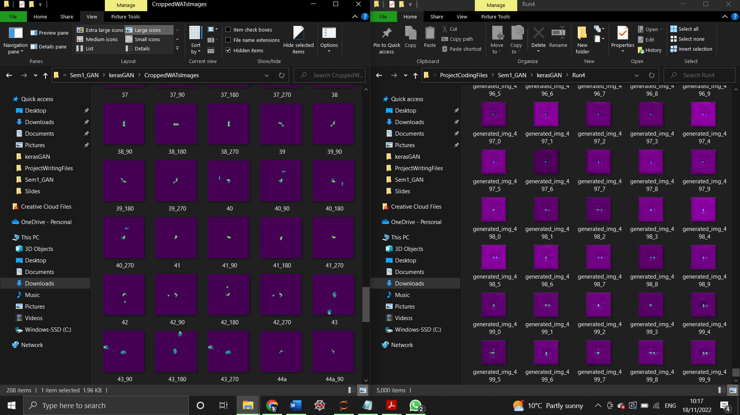



**Friday, 18th November 2022**

* Normalise background then run the GAN
* Fix the size of the produces images

**Tuesday, 22nd November 2022**

Progress since last Tuesday:

* Got rid of the white background and obtained cropped images
* Applied data augmentation by rotating the images
* Ran GAN for 500 epochs
* Developed ideas for improving algorithm:
  + Normalise the background by applying threshold filters (Gaussian filter)
  + Fix the size of generated images

Goals for this week:

* Make plots for losses for generator and discriminator

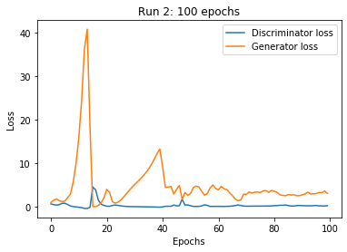 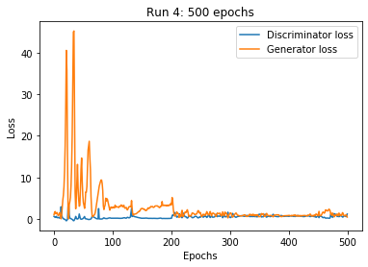

*Note: peak at ~ 70 epoch is erroneous as exponent was ignored due to time constraints :/*

* **BluBEAR GPU Prioritise – and include this in Groningen application, email Ian when submitting application.**
* Normalise the background by applying threshold filters (Gaussian filter)
* Make synthetic images for the training set using gaussian blobs made in 2D
* Fix the size of generated images
* Augmentation further via: blurring, skewing, rotating
* Change the learning rate and observe (increase the learning rate for 100 epochs)
* Proto-training set – download all FIRST data by Sunday evening
* Download 15 MeerKAT images and convert into images
* Read Aniyan paper again
* Find circles in images <https://stackoverflow.com/questions/60637120/detect-circles-in-opencv>

**Wednesday, 23rd November 2022**

BluBear: <https://intranet.birmingham.ac.uk/it/teams/infrastructure/research/bear/bluebear/portal/logging-on.aspx>

**Tuesday, 29th November 2022**

* Previously done: have a framework ready for image classification
  + Needs doing: sample images for WATs and NATs
* Ongoing: BluBEAR online course
* Normalising background with Gaussian filter/thresholding – Done
* Now convert this into a function

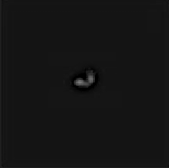

* Skewing and augmenting the image further

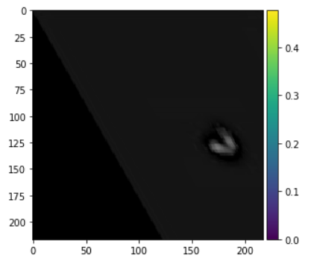🡪 0.6 shear

* Decided that best method to augment images is using tensorflow image augmentation where images are tensors and not just numpy arrays with images.
* See TensorFlow image classification tutorial:

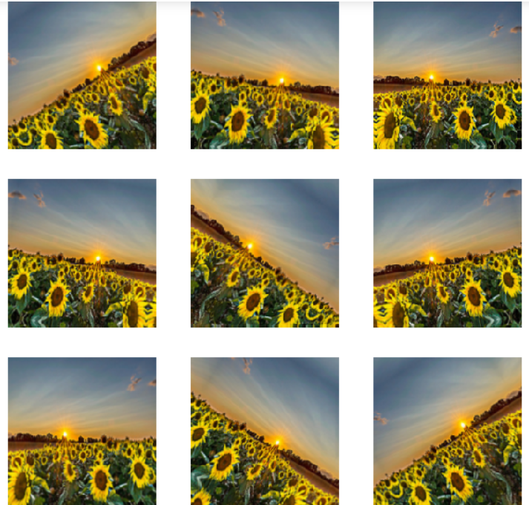

See this: <http://localhost:8888/notebooks/Downloads/Cloud_Detector_Internship/2021/TensorFlow/Tensorflow.org_Tutorial.ipynb>

Meeting Notes

* Preliminary report is 4 pages plus references
* Sections: Introduction, Background: literature review of other papers (Aniyan, WGAN June 2022 paper, see ADS results for neural network radio astronomy papers), WATs, NATs, FR I, FR II; data information (show images examples); methods (mainly what worked, only little bit on what did not work i.e the blob detection), MeerKAT info (resolution, baseline distance, etc.), describe catalogs and source table (mine would be FIRST fits files), describe neural networks, the GAN and its specifications, preliminary results, and project plan for semester 2 🡪 have you covered all the bases and time constraints (how long to construct neural network) – plan for semester 2 can be a Gantt chart or a table describing weekly goals 🡪 seminar is week 7 of Semester 2 i.e March 17th, account for prep time for this. Leave some time to write-up the final report.
* Scientific content, project planning out of 30 each, project overview out of 20, presentation out of 20
* For project work:
  + Github with programming files, README file, pdf of journal, upload FIRST files too as long as not too large

**Sunday/Monday 4th/5th December 2022**

What I want to do:

* Generate better images
* ~~Download all FIRST images~~
* ~~Augment by rotating thrice~~
* Run for 100 epochs overnight

**Run 5**

**Started on Monday, 4th December ~ 3 am**

|  |  |
| --- | --- |
| ***Parameters*** | |
| **Activation function for final layer** | Sigmoid |
| **Number of WATs images** | 348 |
| **Number of epochs** | 500 |
| **Learning rate** | 0.0001 |
| **Number of training images** | 1392 |
| **Generator and discriminator loss plot** |  |

Been two days and it’s still running – Update: **Tuesday, 6th December 21.32** finally finished

**Tuesday, 6th December 2022**

* Goal: make plot for G and D loss and gain

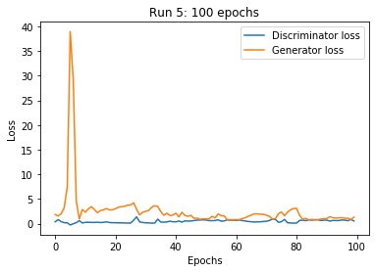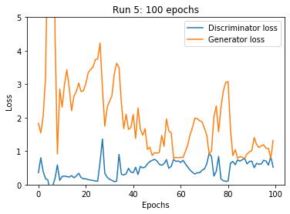

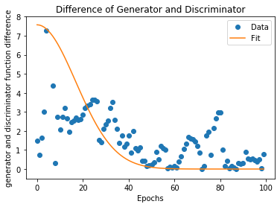

**Semester 2**

**10th Jan 2023, Tuesday**

|  |  |
| --- | --- |
| **Epochs** | 500 |
| **Learning rate** | 0.001 (previously 0.0001) |
| **Number of training images** | 1392 |
| **Plot for GD difference** |  |
| **Standard deviation of fit** |  |
| **Number of images generated per input image** | 5 |
| **Results folder** | Sem2_Run1 |

Started run 18.30 evening, will leave running for a while

**24th Jan 2023, Tuesday**

Find way to save machine learning model results without having to copy paste (see what I did for internship)

<https://www.kdnuggets.com/2021/02/saving-loading-models-tensorflow.html>

Asking on stackexchange

Also – login to BluBEAR

Increase image sizes

Stopped Run because needed laptop CPU power for exams

***Coding file: kerasDCGAN_v2.ipnyb*** *in sem 2 coding files folder*

Goals for today:

* ~~Save GAN results~~
* Make script to run on BluBear – ~~did research~~
* Make a table (excel sheet for different parameters to test out with the GAN)
* ~~Begin downloading NATs~~
* ~~Finish downloading NATs~~
* ~~Process and crop the NATs~~

To save GAN results:

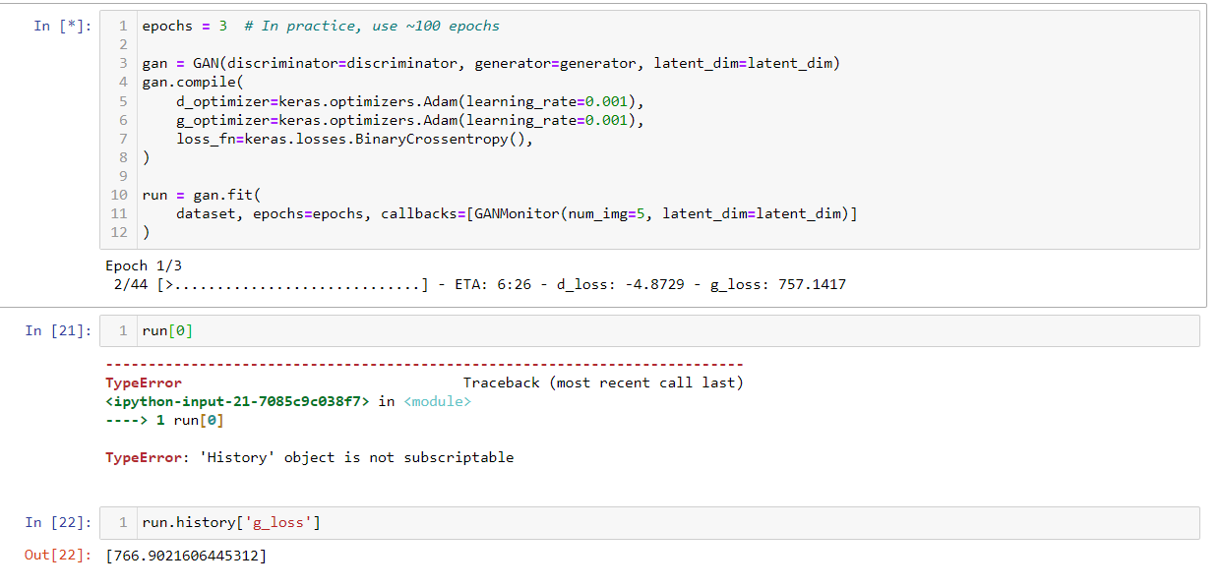

<https://stackoverflow.com/questions/51731207/python-neural-network-typeerror-history-object-is-not-subscriptable>

**Wednesday, 25th January 2023**

Today’s goal

* Make multiclass classification system
* Make GAN for separating guinea pigs from bananas as an efficiency test

Progress Updates for multi-class classification:

* Made multiclass classification
* Now testing with 5 epochs
* Will run for 100 epochs first, then 500 overnight

To download images: <https://images.cv/download/banana/1636/CALL_FROM_SEARCH/%22banana%22>

Progress updates for piggy GAN:

* ***Filename***: kerasPiggyGAN_v2.ipnyb to generate piggy images
* Now running
* Thursday: still running

**Thursday, 26th January 2023**

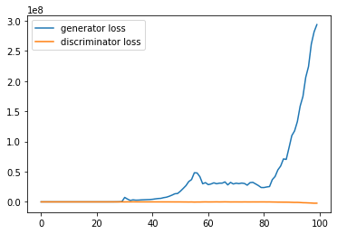 ☹

**Tuesday, 31st January**

Meeting notes

* Week 7 = seminar
* Final report due 5th May (see first Friday in May)

To do:

* For classification neural network:
  + Add more layers (max 7-8 layers)
  + Justify this
  + Combine more activation functions
  + Expand categories to more then FR I and FR II
* For GAN:
  + Add more layers

To detect radio objects:

* Segment image into 9 chunks
* Put chunks with rough white edges in separate folder
* Apply hard threshold
* Detect brightest pixels (top 5), get location and crop
* Then classify manually
* Also detect contours and use this to get filaments

MeerGAN

**Training set: get filaments**

**GAN: BluBEAR for Bananas and piggies**

**N-N : Decide layers**

**Wednesday, 1st February 2023**

Today’s goal:

This: <https://towardsdatascience.com/build-a-custom-trained-object-detection-model-with-5-lines-of-code-713ba7f6c0fb>

TensorFlow equivalent: <https://www.youtube.com/watch?v=-ZyFYniGUsw>

Steps:

1. Use FIRST WATs and NATs and radio sources to train model
2. Use to find objects in MeerKAT test images using link above

Updates:

Filename: RadioDetecto_v1.ipnyb

13:34

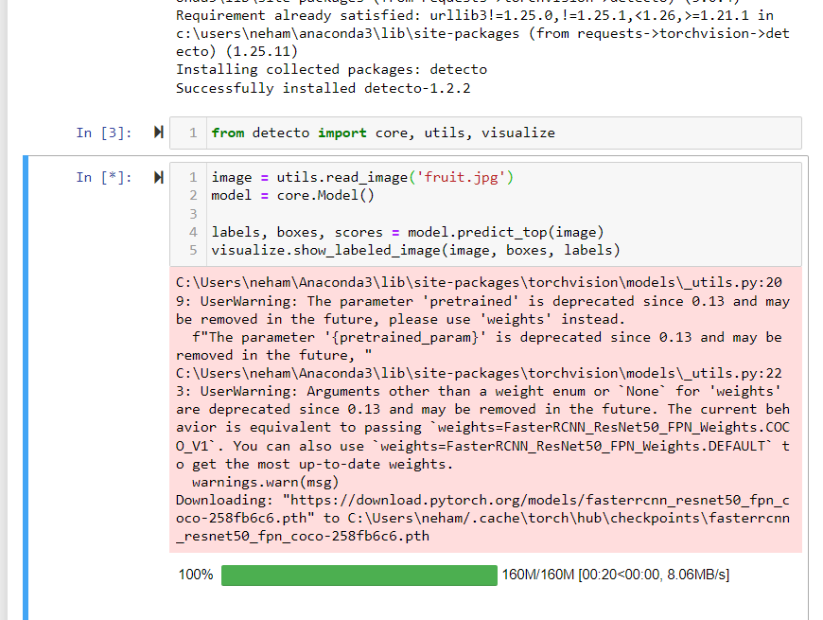

Successfully detected fruits and table 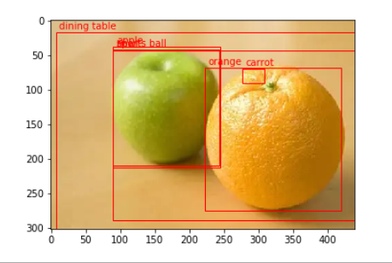

* Key step = label images to make XML format
* Successfully installed labelImg
* Now making individual image labels

**Thursday, 2nd February**

Model runs

Result 1:

J153644-020136_90.jpg

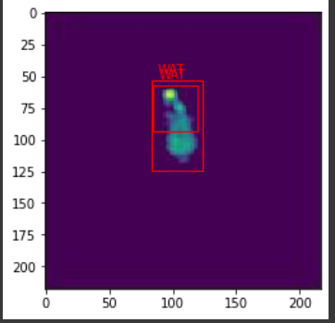

J145001+144747.jpg

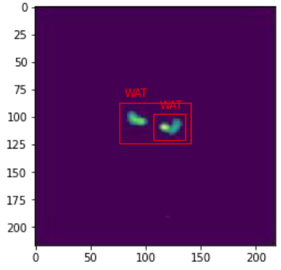

J152126+315733_180.jpg

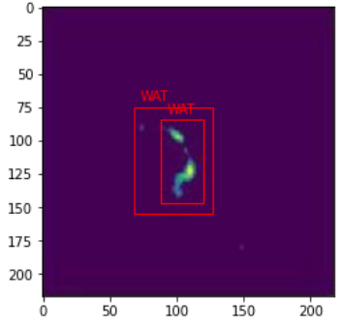

Now testing with FIRST image segments

|  |  |
| --- | --- |
| Image name    G002.5+0.0IFx_Mosaic_Mom0 | **Original unsegmented**  9 segments were made |
| Segment 0 |  |
| Segment 1 |  |
| Segment 2 |  |
| Segment 3 |  |
| Segment 4 |  |
| Segment 5 |  |
| Segment 6 |  |
| Segment 7 |  |
| Segment 8 |  |

**Now testing with second image**

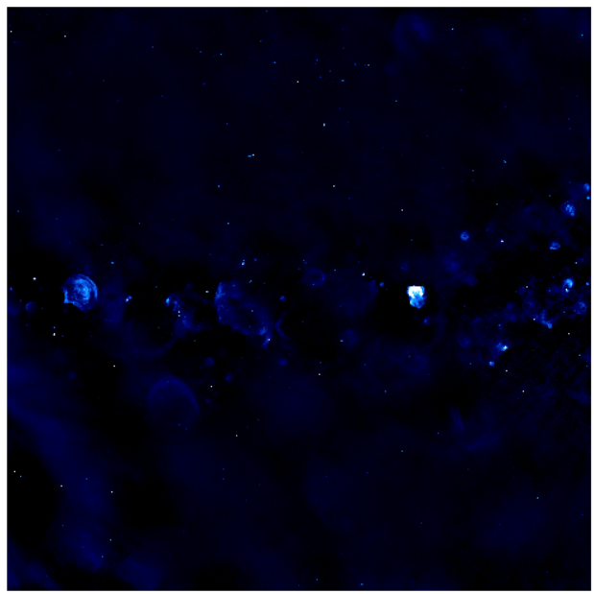**G032.5+0.0IFx_Mosaic_Mom0**

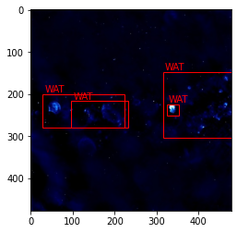

**Making 16 segments**

|  |  |
| --- | --- |
| Segment 0 |  |
| Segment 1 |  |
| Segment 2 |  |
| Segment 3 |  |
| Segment 4 |  |
| Segment 5 |  |
| Segment 6 |  |
| Segment 7 |  |
| Segment 8 |  |
| Segment 9 |  |
| Segment 10 |  |
| Segment 11 |  |
| Segment 12 |  |
| Segment 13 |  |
| Segment 14 |  |
| Segment 15 |  |
| Segment 16 |  |

Next:

1. Transfer all MeerKAT files to GoogleColab
2. Convert all FITS into images in Colab
3. Detect WATs in all images in Colab

Downloaded all MeerKAT files

Now unzipping and uploading to Colab

**Friday, 3rd February**

* ~~Extract all MeerKAT images~~
* ~~Segment and save all MeerKAT images~~
* ~~Run detecto for all MeerKAT images and save resultant images in different directory~~
  + 16 segments is missing out lots of WATs ☹ Do 25 next
* Make detecto database for more WATs
* Upload results to OneDrive
* Email Warrick to book BluBear meeting



Monday

5x5 segments

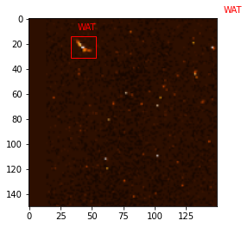

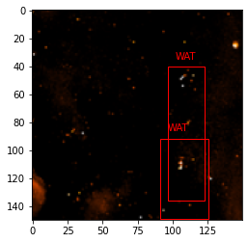

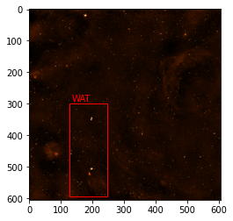

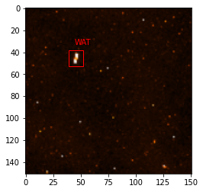

**Meeting Notes, Tuesday 7th February**

To-do:

Use numbers which are not multiples of each other for number of grids – prime numbers are a good shout

* Edge effects – what was an edge becomes a middle
* Read about odd radio circles
* Read about radio galaxies and jets evolutions, make notes on objects detected
* Wavelengths of different astronomical objects (galaxies, stars, radio galaxies)
* Sources and evolution of radio galaxies
* EMU
* ASKAP

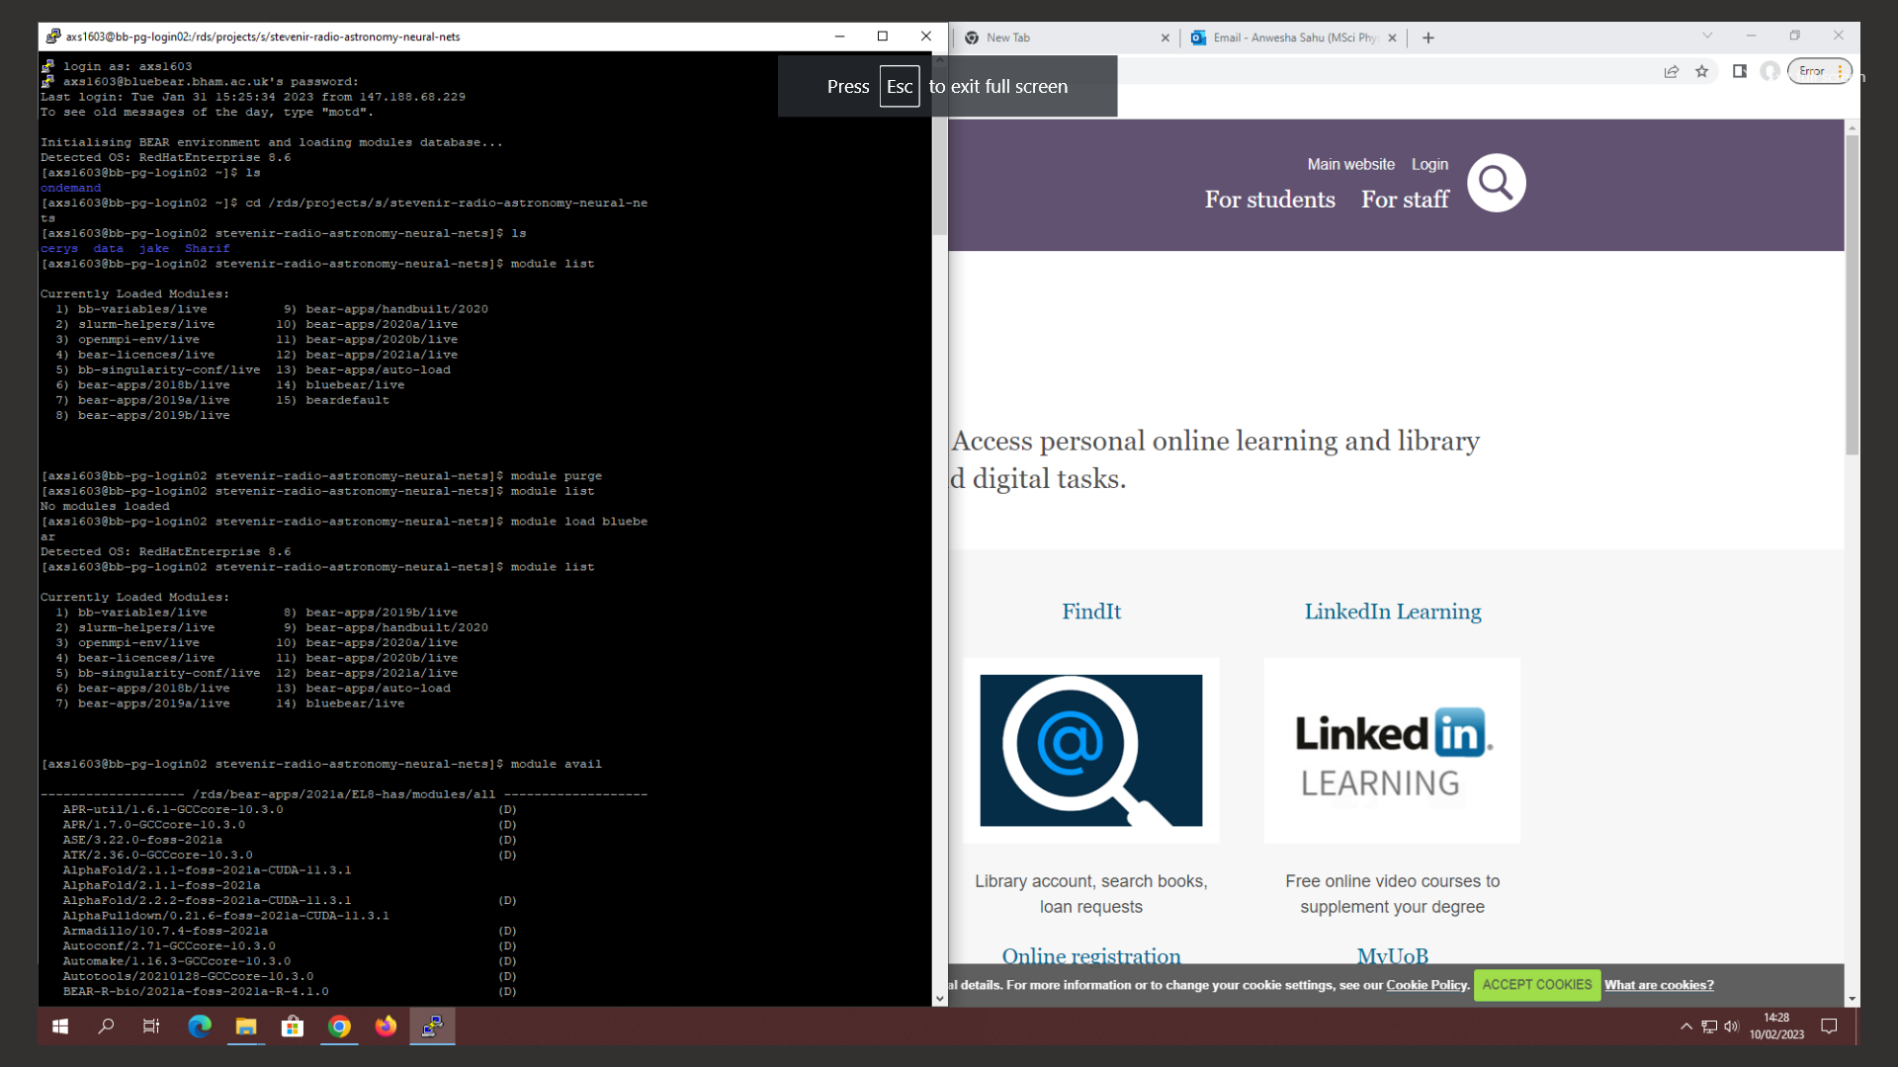

22nd Feb 2023, Wednesday

Updates:

* Ran on BlueBEAR
* Learning rate of 0.001 is too slow. Needs to be at least 0.0001. Now testing the with learning rate 0.0001 and activation functions for D and G RELU, instead of sigmoid.
* Three runs currently ongoing in BlueBEAR – most recent run uses 10 CPUs
* Gained access to GPU too and will run these too
* Seminar on 6th or 7th March

Job 63262778 🡪 meerkat images set 1: 800 epochs, 16 cpu cores, 30 hours

23rd February 2023, Thursday

Bow shocks

1. Kumar, P., Schinzel, F.K., Taylor, G.B., Kerr, M., Castro, D., Rau, U. and Bhatnagar, S., 2023. Resolving the bow shock and tail of the cannonball pulsar PSR J0002+ 6216. *arXiv preprint arXiv:2302.04927*.
   * VLA + radio astronomy + bow shock
2. Sparavigna, A.C. and Marazzato, R., 2010. Observing stellar bow shocks. *arXiv preprint arXiv:1005.1527*.
   * Definition of bow-shocks

Supernova remnants

1. Correlating optical and radio images: Giacani, E.B., Dubner, G.M., Kassim, N.E., Frail, D.A., Goss, W.M., Winkler, P.F. and Williams, B.F., 1997. New radio and optical study of the supernova remnant W44. *The Astronomical Journal*, *113*, p.1379.
   * Multispectral observations

Prospects of radio astronomy

1. Murphy, E.J., 2022. The Role of Radio Observations in Studies of Infrared-Bright Galaxies: Prospects for a Next-Generation Very Large Array. *Universe*, *8*(6), p.329.
   * Cosmology applications

Applications of machine learning in astronomy

1. Rodríguez, J.V., Rodríguez‐Rodríguez, I. and Woo, W.L., 2022. On the application of machine learning in astronomy and astrophysics: A text‐mining‐based scientometric analysis. *Wiley Interdisciplinary Reviews: Data Mining and Knowledge Discovery*, *12*(5), p.e1476.
   * Pattern recognition with machine learning to determine object classes
   * Prospects of AI in astronomy

Today’s Coding tasks:

* ~~Run BlueBEAR with NATs~~
* ~~Run BlueBEAR with cropped MeerKAT images~~
* Check GPU access
* ~~Make list/table/excel sheet with info on run details~~
* Seminar slides outline prepare in word document
* Continue collecting sources
* Research into GAN layers:
  + Plan runs with different number of layers 🡪 include in excel sheet

Weekend coding tasks:

* Detecto:
  + Add NATs
  + Add

**MeerKAT Sources**

* GPU Run
* 800 epochs
* Sigmoid activation functions

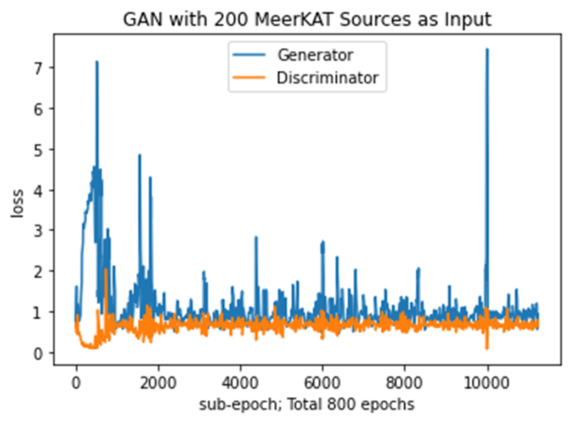

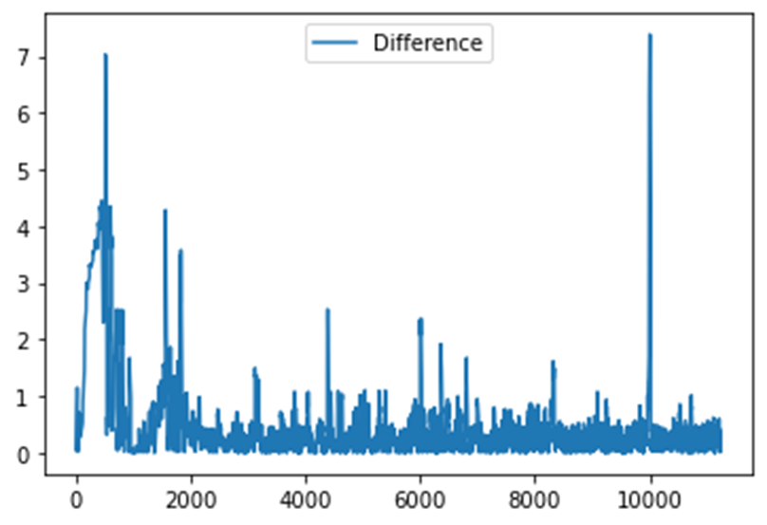

|  |
| --- |
| **Key Steps for Multiclass Classification Algorithm** |
| * Define training set with:   + NATs/WATs     - FIRST VLA     - Synthetic GAN images   + ORCs   + Filaments   + Other * Train Detecto with real NATs * Train Detecto with synthetic MeerKAT images * Run Detecto and extract images * Run multiclass classification on images |

MeerKAT Sources – GPU Run

* 3000 epochs
* Sigmoid activation function

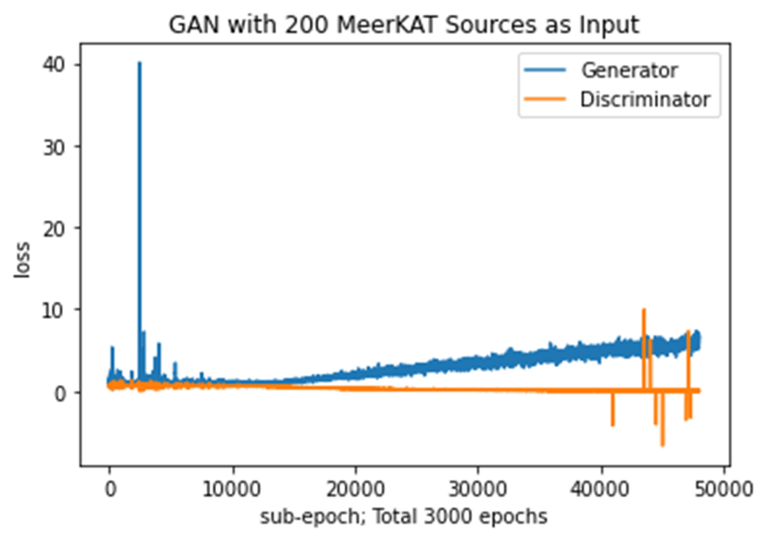

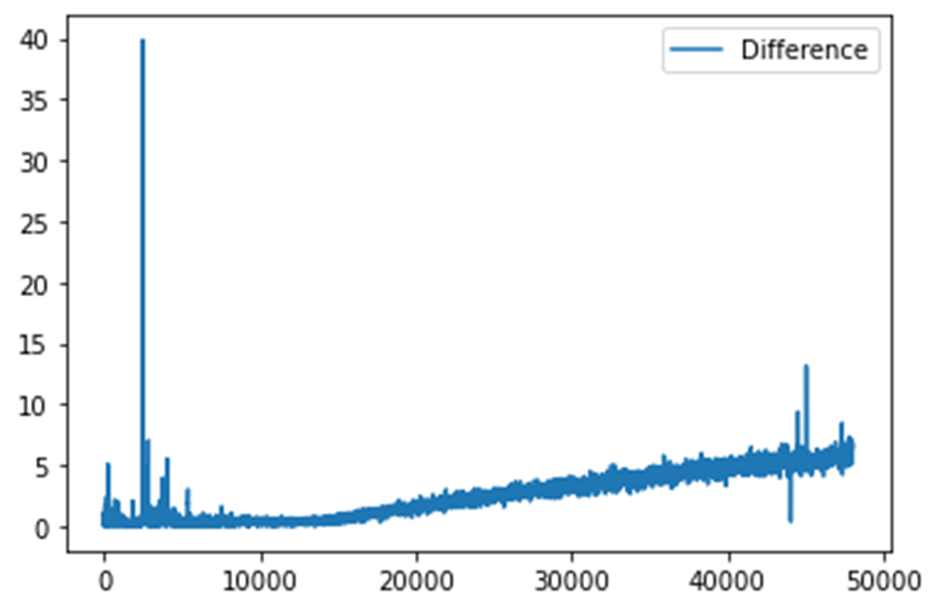

VLA FIRST NATs sources

* 3000 epochs
* Sigmoid activation

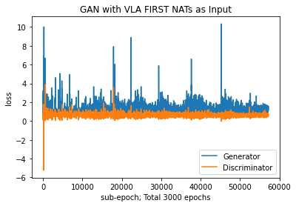

* 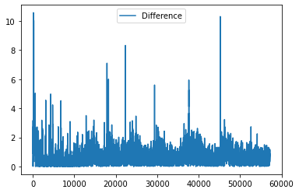

**Seminar Prep**

Overall project structure

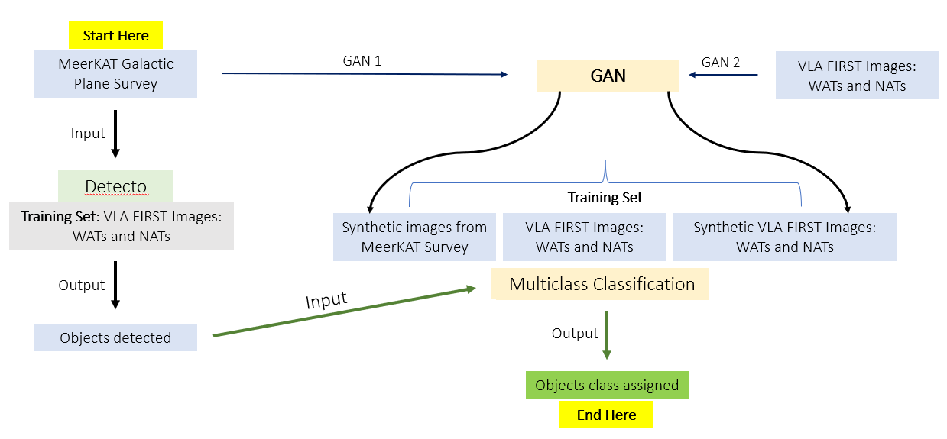

Ian Feedback: this diagram is confusing, try another one

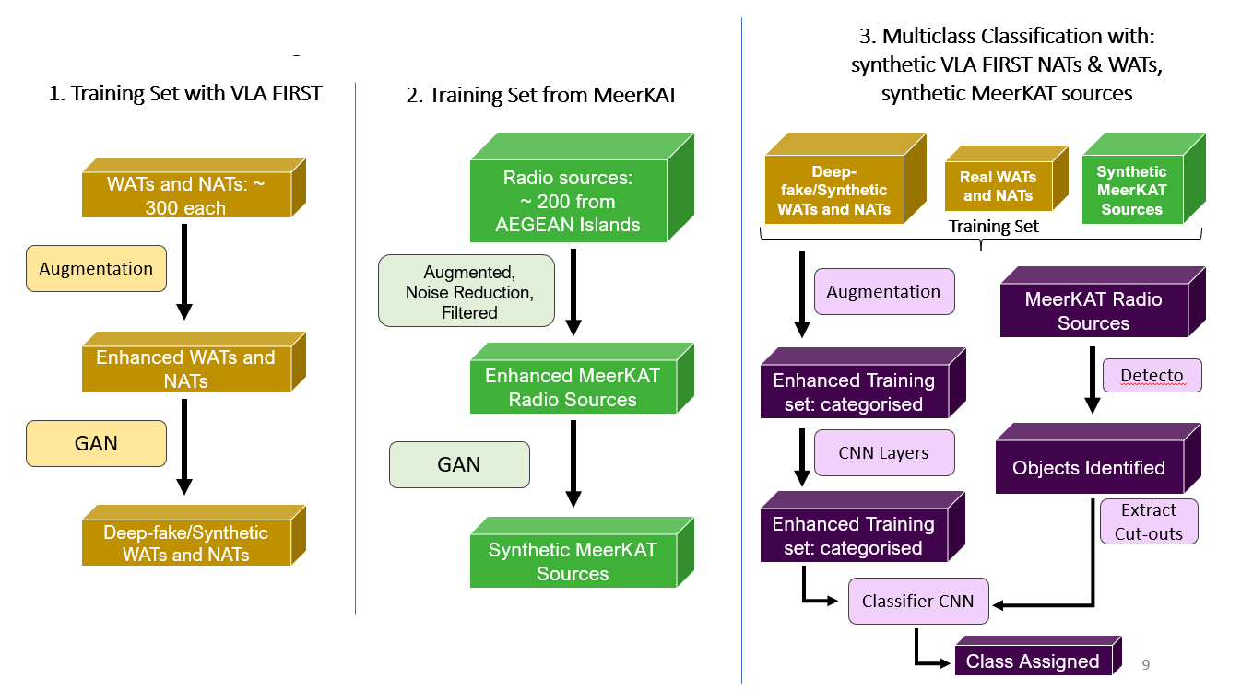

Slides outline:

**Seminar Slides Outline**

1 Title Slide

1 Outline slide with figures

10 body slides

1 Summary slide

3-4 slides with extra plots which may be useful for answering questions

Title

Outline

Body Slides

1. Principles of Radio astronomy
   1. Radio objects
   2. How radio telescope arrays work
2. MeerKAT array and its aims
3. Intro to project and aims
4. Why machine learning and astronomy
5. How does a GAN work
   1. Sketch/diagram of layers and network structure
   2. Label input, output and neural network layers names
      1. (Explain role of each layer verbally)
6. Input images: Pre-processing
   1. VLA FIRST images 🡪 WAT and NAT catalogs from that paper
   2. Augmentation
7. Input images: MeerKAT Images from Chris’s catalog
   1. AEGEAN Island 🡪 talk to Chris about this
8. Architecture of my GAN
   1. Different runs and parameters
      1. Explain parameters meaning verbally
         1. Learning rate
   2. HPC explain + timings
   3. Share produced images
9. Detecto
   1. Trained with FIRST WATs and NATs
   2. Trained with MeerKAT synthetic images
   3. Detect objects in MeerKAT segmented images
10. Results: synthetic images

Summary Slide

Report tips from Ian/my outline ideas:

General tips:

* Plan slides to account for tendency of whether you talk too much or too fast

Background:

* Neural networks
* Radio astronomy
* Applications of GANs
* Objects of interest: WATs and NATs – why important? Because are traces of clusters and tell us about jets and the environment they move in, AGNs + black hole connection (as audience will include Patricia)
* Why are these objects important?
* Set the scene on why we are doing this strongly

Interesting bits:

* Make a time lapse video for generated images
* Learning rate explain impact
* Make diagram to show relation between the stages for processing the images (filtering, augmenting, GAN images, how went from 30 sources to 30,000 sources)
  + Block flow diagram
  + Chain diagram
  + 3D block flow diagram
  + Layers and connection for NNs

**13th March, Monday**

Meeting notes:

* Size scales of images (large and small i.e degree and arcseconds)
* Punchline in summary: find new objects for WATs and NATs which will be subject of new studies in the future – make it evident what the goal of the project is
  + Audience should clearly see what are the two/three things they should take away
* Add bits about testing out other activation functions 🡪 test with dataset on radio objects;
  + Demonstrate that you have thought about multiple activation functions.
* Intelligent discussion and evidence of understanding with different activation functions
* Justify each step of the network

**To do:**

* Build multiclass model
* Check if all MeerKAT images downloaded
* Segment into 5x5 and 4x4
* Get coordinates of sources
* Extract them
* Call them objects of interest OOI
* Multiclass classify them
* Pick one final class of segmentation
* In report, stick with decisions and justify them
* Have the WAT sources as an appendix
* Montage of images
* Strengths and weaknesses of image classification – see critical paper
* Appreciate the blurry line in saying WAT could be NAT i.e fuzzy language so problem isd that objects and fundamentally fuzzy at the edges and this needs to be accounted for

**Easter break update:**

* Figured out how to crop segments from Detecto
* Ran multiclass classification and got > 90% accuracies

**Tuesday, 11th April 2023**

1. Currently running Detecto, getting coordinates of segments and then cropping them out
2. Done above
3. Now running multiclass model
4. Next will save model
5. Will run model to get predictions for cropped images
6. Also asked Chris for access to all MeerKAT source catalog images
7. All above done

* Overfitting for over 95% accuracies validation
* 200 epochs ongoing
* Accuracy dropped
* Over 70% so acceptable

**18th April 2023, Tuesday**

**Report goals today:**

* Radio astronomy object details
* GANs
* Issues with radio astronomy
* MeerKAT project details

**Project Idea:**

- Get more synthetic WATs and NATs and run through multiclass

**19th April, Wednesday**

Testing multiclass on NATs:

|  |  |
| --- | --- |
| **Image** | **Class Assigned** |
|  | This image most likely belongs to NAT with 100.00 % confidence. |
|  | This image most likely belongs to NAT with 92.44 % confidence. |
|  | This image most likely belongs to WAT with 92.60 % confidence. |
|  | This image most likely belongs to WAT with 64.43 % confidence. |
|  | This image most likely belongs to NAT with 98.59 % confidence. |
|  | This image most likely belongs to WAT with 69.25 % confidence. |
|  | This image most likely belongs to WAT with 96.27 % confidence. |
|  | This image most likely belongs to NAT with 100.00 % confidence. |
|  | This image most likely belongs to WAT with 68.21 % confidence. |
|  | This image most likely belongs to NAT with 62.69 % confidence. |
|  | This image most likely belongs to NAT with 85.90 % confidence. |
|  | This image most likely belongs to NAT with 99.98 % confidence. |
|  | This image most likely belongs to WAT with 53.97 % confidence. |
|  | This image most likely belongs to NAT with 65.94 % confidence. |
|  | This image most likely belongs to NAT with 100.00 % confidence. |

**Week 10 plots:**

* 200 epochs multiclass plot
* Run GAN to get test images again
* Run test images on multiclass classification and get probability distribution
* Collect all plots in one place

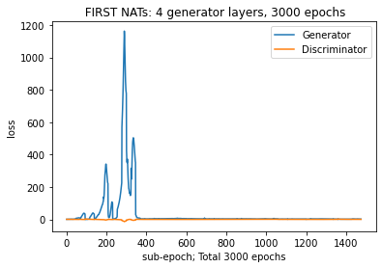

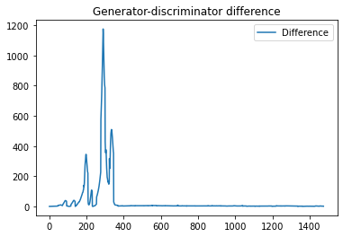 difference from plot above

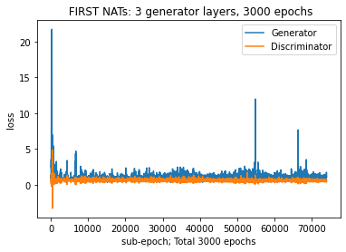

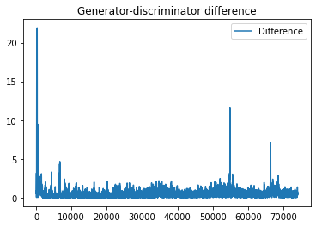for above plot

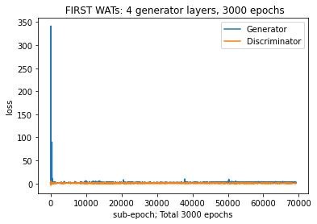

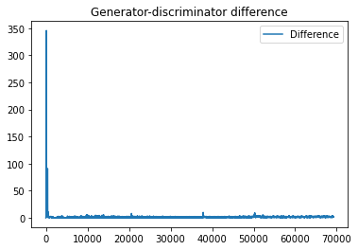

For MeerKAT GPS:

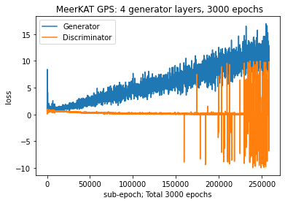

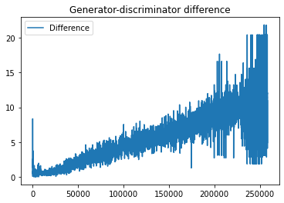 overfitting because increase in difference – see one of the references on GANs and machine learning when writing in report

**Multiclass**

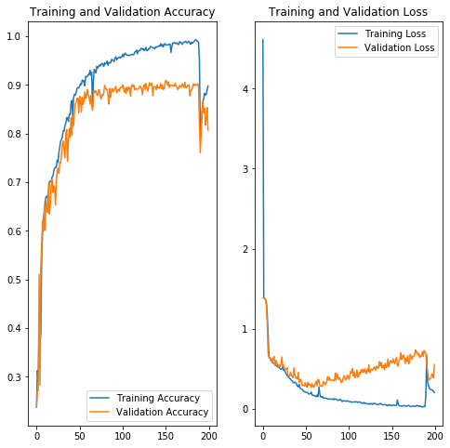

Overfitting and decrease in accuracy but always above 70% - discuss this in report in more detail with reference to classes assigned, get probability plots

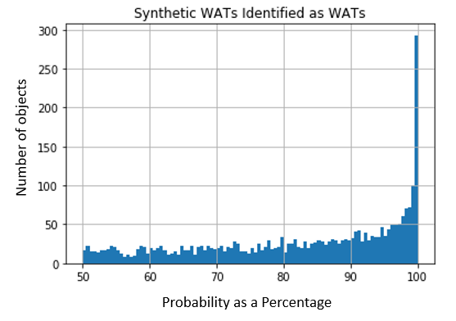

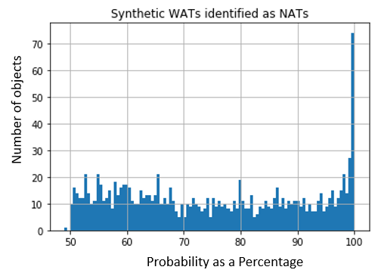

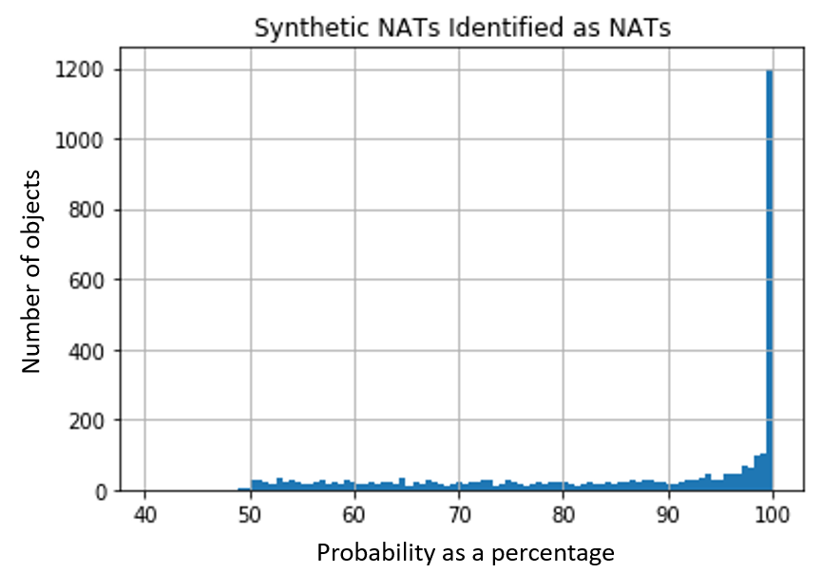

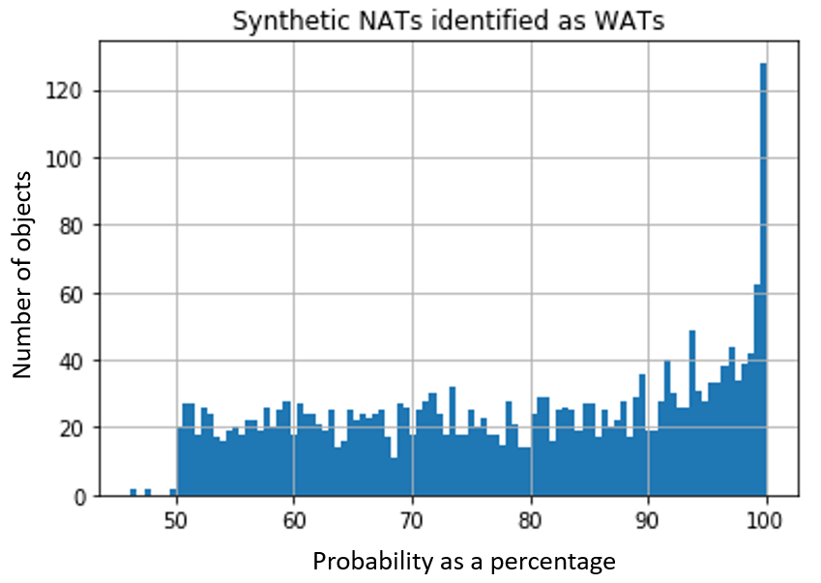

Now MeerKAT synthetic images tested

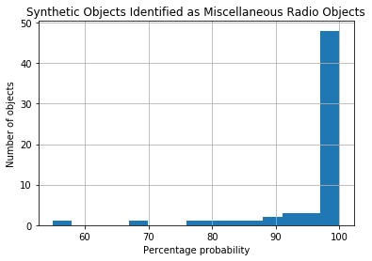

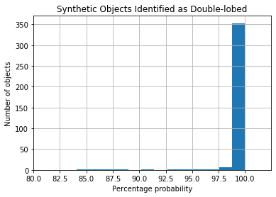

See paper on #tags for prospects section and include figure 3 below in report

